The retail and e-commerce industries categorize apparel by grouping products into Womenswear, Menswear, and Unisex/Gender-Neutral divisions, which are further divided into functional garment categories and hyper-specific leaf subcategories. [1, 2]
The primary categories and subcategories of apparel broken down by gender are structured below.
👗 Womenswear (Women's Apparel)
Women's clothing structure accounts for specialized silhouettes, formal variations, and highly segmented foundational pieces.
- Tops & Blouses
  - Blouses (button-front, wrap, peplum)
  - T-shirts, tank tops, and camisoles
  - Crop tops and bodysuits
  - Tunics and kaftans
- Bottoms
  - Skirts (maxi, midi, mini, pencil, pleated)
  - Pants (wide-leg, trousers, straight, skinny)
  - Jeans (high-rise, mom jeans, boyfriend fit, flares)
  - Shorts (denim, high-waisted, bike shorts)
- Dresses & One-Pieces
  - Casual dresses (sundresses, maxi, shirt dresses)
  - Formal/Evening gowns and cocktail dresses
  - Jumpsuits and playsuits/rompers
- Outerwear
  - Coats (trench, wool, puffer)
  - Jackets (blazers, denim, leather, moto)
  - Cardigans, sweaters, and kimonos
- Activewear & Athleisure
  - Sports bras
  - Leggings and yoga pants
  - Tracksuits and tennis skirts
- Lingerie & Sleepwear
  - Bras and bralettes
  - Panties (briefs, thongs, boyshorts, seamless)
  - Shapewear and corsets
  - Nightgowns, robes, and pajama sets
- Swimwear
  - Bikinis (mix-and-match tops and bottoms)
  - One-piece swimsuits
  - Cover-ups and sarongs

👔 Menswear (Men's Apparel)
Men's clothing relies heavily on structural tailoring, specific collar constructions, and waist/length measurements. [1, 2]
- Tops & Shirts
  - Dress shirts (oxford, poplin, twill)
  - Casual button-downs (flannel, chambray, short-sleeve)
  - T-shirts (crewneck, V-neck, graphic)
  - Polo shirts and henleys
- Bottoms
  - Trousers and dress pants
  - Chinos and khakis
  - Jeans (straight, slim, relaxed, athletic taper)
  - Shorts (cargo, chino shorts, athletic shorts)
- Suits & Tailoring
  - Suit jackets, blazers, and sport coats
  - Tuxedos and formal vests
  - Suit trousers [1, 2, 3]
- Outerwear
  - Jackets (bomber, denim, field, harrington)
  - Coats (overcoats, parkas, raincoats)
  - Hoodies and sweatshirts
  - Sweaters (V-neck, crewneck, quarter-zip) [1]
- Underwear & Sleepwear
  - Boxers and briefs
  - Boxer briefs and trunks
  - Undershirts (tanks, crewnecks)
  - Pajama pants, robes, and loungewear [1, 2, 3]
- Activewear & Sportswear
  - Gym shorts and training tights
  - Performance muscle tees and jerseys
  - Tracksuits and windbreakers [1]
- Swimwear
  - Swim trunks and board shorts
  - Speedos and swim briefs [1, 2]

🧥 Unisex & Gender-Neutral Apparel
This fast-growing industry segment focuses on versatile, relaxed cuts, universal sizing, and designs that completely avoid traditionally gendered silhouettes. [1, 2]
- Streetwear & Basics
  - Oversized hoodies and crewneck sweatshirts
  - Boxy-fit t-shirts and drop-shoulder tops
  - Joggers, sweatpants, and cargo pants [1, 2, 3]
- Workwear & Utility
  - Utility jackets, chore coats, and shackets
  - Overalls, boiler suits, and coveralls [1, 2]
- Loungewear
  - Plush robes, fleece sets, and slide slippers

🧳 Universal Apparel Categories (Segmented by Gender)
While these macro categories apply across all genders, brands still separate their inventory patterns internally to match male or female sizing models. [1, 2, 3, 4]
- Footwear: Segmented into Men's/Women's lines for sizing but share identical subcategories like Athletic (running shoes, sneakers), Formal (heels, loafers, dress shoes), and Boots.
- Accessories: Segmented or shared items including Hats/Caps, Socks, Belts, and Gloves/Scarves. [1, 2, 3, 4, 5]

Dress codes are the written or unwritten rules about what is considered appropriate clothing for a certain occasion, situation, or event. For example, wearing formal attire in the workplace, the flexibility to dress more casually on Fridays, or the word "cocktail" at the bottom of an invitation can be seen as reflections of dress codes in daily life. Dress codes are closely linked to workplace culture, the type of event, and social norms, while also enabling women to create their own style.
In Collectif London's vintage-inspired collections, which are designed with modern cuts while drawing inspiration from past decades, you can find clothes suitable for various situations and occasions. From tea dresses for afternoon meetings with friends to pencil skirts and blouses you can wear in the workplace, Collectif London's designs help you dress appropriately for many settings and different dress codes.

What are the Well-Known Dress Code Types for Women?
Dress codes, sometimes stated explicitly on an invitation but more often defined by the type of event, organisation, or setting, are the unwritten fashion rules. The dress code types can help to determine the level of formality, relaxation that is appropriate for an occasion.
Job interviews, business meetings, the workplace, weddings, cocktail parties, and dinners with friends all require different styles of dress. Casual, smart casual, and business casual dress code requirements, as well as formal dress styles, are shaped by the correct combination of many details, from the cut of the clothes to the fabric, and from the heel height of the shoes to the choice of handbag and accessories.
Even so, dress style categories should not be viewed as rigid and unchanging. When understood or interpreted correctly, the same clothing can be adapted to more than one setting with different shoes, bags, and jewellery. The aim is to use clothing rules not as restrictions, but as practical guides in choosing appropriate elegance for the situation.
Dress Code Type | Formality Level | Settings or Events | Main Pieces
Casual Dress Code | Lowest formality, highest freedom | Holidays, shopping, weekends, and relaxing with friends | T-shirts, polo shirts, casual shirts, jeans and chinos, tea dresses, loafers or sandals
Smart Casual Dress Code | Between casual and business formal, chic but also relaxed | Office without strict suit rules, business lunches or office to evening days | Blazers, classic but comfortable trousers, dark non-distressed denim, midi dresses, basic blouses
Business Casual Dress Code | More formal than smart casual, less formal than full business | Modern workplaces, meetings, presentations, and office days | Tailored trousers and skirts at or below the knee, pencil dresses, shirts, and knitwear; neither too tight nor too loose.
Semi-formal Dress Code | Mid–high formality, but elegant | Daytime work events, civil ceremonies, graduations, and outdoor receptions | Knee-length or midi dresses, elegant but not bold jumpsuits, skirt and jacket outfits, little black dress.
Cocktail Dress Code | Between semi-formal and formal, party-ready | Evening receptions, cocktail-format events, engagement parties, New Year's, romantic dinners, Valentine's Day | Dresses above the knee, at the knee, or midi length, with richer colours, high or slim heels, small evening bags, jewellery.
Formal Dress Code | High formality for work and evening | Corporate events, formal business dinners, gala evenings, protocol receptions, and evening ceremonies | Tailored blazers with trousers or skirts, below-the-knee dresses, dark suits. Long or ankle-length dresses or suits.
Black Tie Dress Code | Very high evening formality | Galas, high-profile evening weddings, award nights, and prestigious receptions | Floor-length or at least ankle-grazing dresses, deep tones (black, navy, emerald, burgundy) with accessories, high or slim heels.
White Tie Dress Code | The highest, ceremonial level of formality | State dinners, royal events, historic galas, ultra-formal occasions | Full-length or ball gown, usually one-piece. Off-the-shoulder, strapless, or deep necklines.

Comfort and Elegance in One With The Casual Dress Code
The casual dress code is characterised by the lowest level of formality and the greatest freedom. However, this does not mean careless or untidy. The casual style creates a clean, comfortable daily look with high-quality, well-fitting pieces. In casual dress combinations, basic t-shirts, polo shirts, jeans, chinos, simple dresses, trainers, loafers, or minimal boots are generally used together. Jersey, denim, linen, and cotton-blend are the main fabric groups in this code. Even though neutral tones generally dominate the colour palette, bright colours can be used on certain pieces, like belts or bags, to enliven the appearance. During holidays, shopping, and weekend meet-ups with friends, those who wish to look smart without challenging the rules can combine comfort and style with a casual dress code.

Smart Casual Dress Code for Women Style Tips
The smart casual dress code is a way of dressing positioned between casual and the classic business style. It sits between everyday comfort and the strict lines of formal wear; therefore, answers to the question 'What is the smart casual dress code?' generally describe a neat, carefully put together look between the two. Especially in office cultures where there are no strict dress codes, like wearing a suit, but clothing choices are still expected to be appropriate for professional business life, the smart casual style is a lifesaver.
Blazers, classically but comfortably cut trousers, dark, non-distressed denim, midi dresses, and simple blouses play an important role in smart casual style. You can easily create a smart casual look by pairing 70s vintage-inspired flared jeans with a 50s-style polka dot top, or a 40s and 50s-inspired blazer jacket with a midi skirt.

Business Casual Dress Code for Women for a More Formal But Comfortable Style
The business casual dress code is a style of work attire in which the classic suit culture has been relaxed, but a professional appearance is still important. As the need for comfort in the workplace increased in the 1980s and 1990s, the question of "What is business casual dress code?" became much more widely discussed. When mentioning business casual, the main aim is to create neat, professional-looking outfits that are suitable for a professional life without having to wear a full suit. In this style, well-tailored trousers or skirts that fall at or just below the knee, simple dresses, shirts, and fine knitwear are appropriate; pieces should not be too tight or overly loose.

Semi-Formal Dress Code for Daytime Events
Semi-formal dress style is a good choice for attending daytime work events, civil ceremonies, graduations, and outdoor receptions with a garden party dress code, requiring elegance and grace, but not ostentation. Knee-length or midi dresses, elegant but understated jumpsuits, and flattering skirt-jacket combinations, especially the little black dress, are suitable for the style. You can also use accessories to add a little dynamism to the look, like a colourful necklace, high-heeled shoes, or earrings. You can easily create a semi-formal dress code by pairing a 50s-inspired pencil dress with a fitted short jacket, or a structured midi dress with a bolero and classic heels.
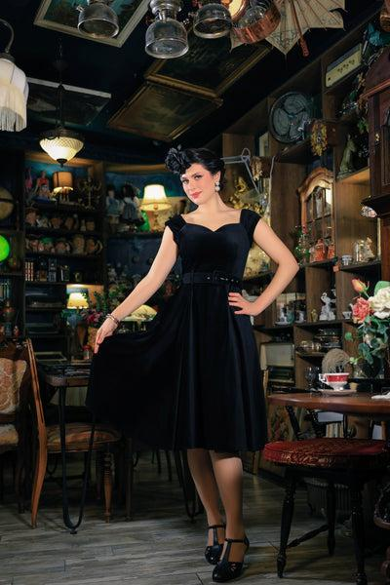

Cocktail Dress Code for Evening Celebrations
Cocktail dress code is one of the dress style categories used especially for evening and night events, starting after 4 p.m., positioned between semi-formal and formal dress styles. It does not require a full-length gown; dresses that fall above the knee, at the knee, or at midi length form the basis of the style. More luxurious fabrics like satin, silk-blend crepe, velvet, and lace are used together with rich colours, metallic textures, and controlled sparkle details.
Compared with the semi-formal style, a more party-ready and showy look is targeted, but one that is not as strict as black tie. It is ideal for evening dress code for weddings, receptions, corporate events in cocktail format, New Year's Eve celebrations, engagement parties, and special celebratory dinners; for romantic evening meals, and especially in Valentine's Day dress code expectations. You can build a cocktail outfit by choosing a velvet 50s style dress with an evening bag, or a wrap dress with statement earrings and high heels.

Formal Dress Code for Women in Professional and Evening Settings
Formal dress code is one of the highest levels of elegance and seriousness in both professional life and evening events. In business life, well-tailored blazers complete with dress trousers or a skirt, below-the-knee sheath dresses, and simple, dark-coloured suits can be preferred for a formal look.
Additionally, at evening events, full or ankle-length evening dresses, and in some cases tuxedos or suits tailored for women, can be ideal. Luxurious fabrics like silk, satin, velvet, tulle, and lace, combined with clean finishes, provide a style that is not as strict as the black or white tie dress code, but carries a similar level of respect and formality. It is suitable for gala dinners, corporate award ceremonies, protocol receptions, and evening weddings. You can create a formal look by choosing a glitter maxi dress, or by pairing a 40s-inspired puppytooth blazer with wide-leg tailored trousers and classic heels.

Black Tie Dress Code for Evening Elegance Decoded
Black tie dress code is a dress style that significantly raises the level of formality for evening and night events, but is less formal than the ceremonial strictness of white tie. For anyone wondering "What is black tie dress code?", the basic expectation is a floor-length or at least ankle-grazing dress in silk, satin, velvet, chiffon, or fine lace. Generally, clean shoulder lines, fluid skirts, and well-balanced necklines are acceptable for black tie.
Black is always a safe option, but deep tones like navy, emerald, or burgundy can also be chosen, especially when paired with well-considered accessories. Slim or high-heeled shoes, a small evening bag, and jewellery pieces complete the look.

White Tie Dress Code for The Prestigious Events
White tie dress code is the most formal clothing rule, sitting at the highest level in the hierarchy of dress code categories and often referred to as "full evening dress". Historically associated with aristocracy, the code is still seen today at state dinners, protocol organisations, galas, or other prestigious events. Women are expected to wear a floor-length evening or ball gown, and off-the-shoulder, strapless, or deeply décolletage styles are acceptable. Silk, satin, tulle, organza, fine lace, pearls, sequins, and crystal detailing can also be used; ostentation is not forbidden, but rather expected. Classic evening makeup, a small but luxurious evening bag, and glamorous jewellery complete the look, and not wearing a watch is one of the unwritten rules of the white tie dress tradition that still exists today.
Whether the invitation calls for smart casual, semi-formal, cocktail, black tie, or even white tie dress code, Collectif London's vintage-inspired dresses make it easier to interpret each code in your own way. Explore the collections to find appropriate pieces for your personal style.

Frequently Asked Questions About Dress Codes

Why is the Dress Code Important?
Dress codes are one of the simple ways of setting a level of formality, showing respect for the occasion, and preventing underdressing or overdressing. They also simplify the process of choosing dresses by narrowing the options to what is appropriate for the event.

What are the Dress Codes for Weddings?
Weddings usually range from semi-formal to black tie. Daytime ceremonies often call for semi-formal or garden party dress codes, while starting after 4 p.m., evening receptions lean towards cocktail attire. More traditional weddings may necessitate formal or black tie dress codes on the invitation.

What Dress Code is Semi-Formal?
A semi-formal dress code is more formal than smart casual, but less formal than cocktail. Typically, this means knee-length or midi dresses, elegant jumpsuits, or skirt-and-jacket outfits. It is common for daytime weddings, graduations, and business receptions.

What is the Difference Between Smart Casual and Business Casual?
Smart casual is a smart but relaxed style, with pieces like blazers, dark jeans or chinos, midi dresses, loafers or block heels. Business casual is more office-focused with tailored trousers or skirts, shirts, and simple dresses.

Are Jeans Appropriate for a Business Casual Dress Code?
In more relaxed modern offices, dark, non-distressed, well-fitting jeans can be acceptable when styled with a blazer, shirt, and smart shoes.

A dress code sets the tone for an event and provides a helpful guideline for guests as they plan their attire. For everything from professional networking events and office holiday parties to formal charity galas and weddings, the different types of dress codes cover a broad spectrum of appropriate clothing options for a wide array of soirées.
When hosting any type of event, deciding on a dress code early on in the planning process and communicating it clearly in your invitation allows you and your guests to prepare accordingly. Your event’s dress code and corresponding formality level will also potentially inform or pair with other important planning decisions such as décor or venue, so select wisely!
Let’s break down what specific dress code types mean and how they can work to elevate your event, whether you’re planning a swanky cocktail party, an opulent ball, or anything in between.
Table of Contents
- 1. White tie
- 2. Black tie
- 3. Cocktail
- 4. Semi-formal
- 5. Casual
- Send in style with Paperless Post

1. White tie

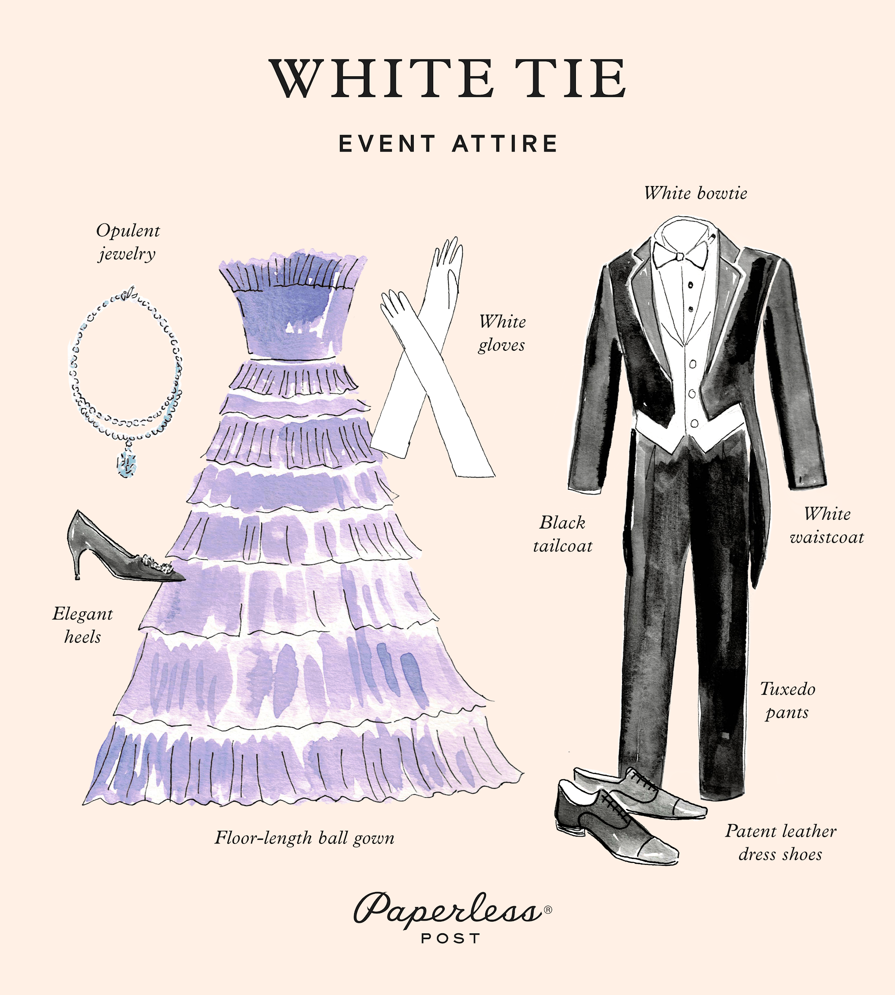
Starting with the most elegant dress code, we have white tie. A white tie event means dressing in your absolute finest. Think White House presidential. Think Royal Ball. Think 10-course dinner with the Dowager on “Downton Abbey.”
If you want your guests to feel like they’ve stepped into a decadently divine evening, a white tie dress code can certainly help bring that vision to life. If you’re hosting an elegant gala, formal wedding, or other high-caliber event, include clear attire expectations in your invitation, and get ready to see some impressive levels of glamour.
Examples of white tie attire include:
- Formal floor-length gowns
- Black jackets with tails
- White vest
- Tuxedo pants
- White bowtie
- Polished dress shoes
- Dazzling jewelry
- Tiara
- Gloves

2. Black tie

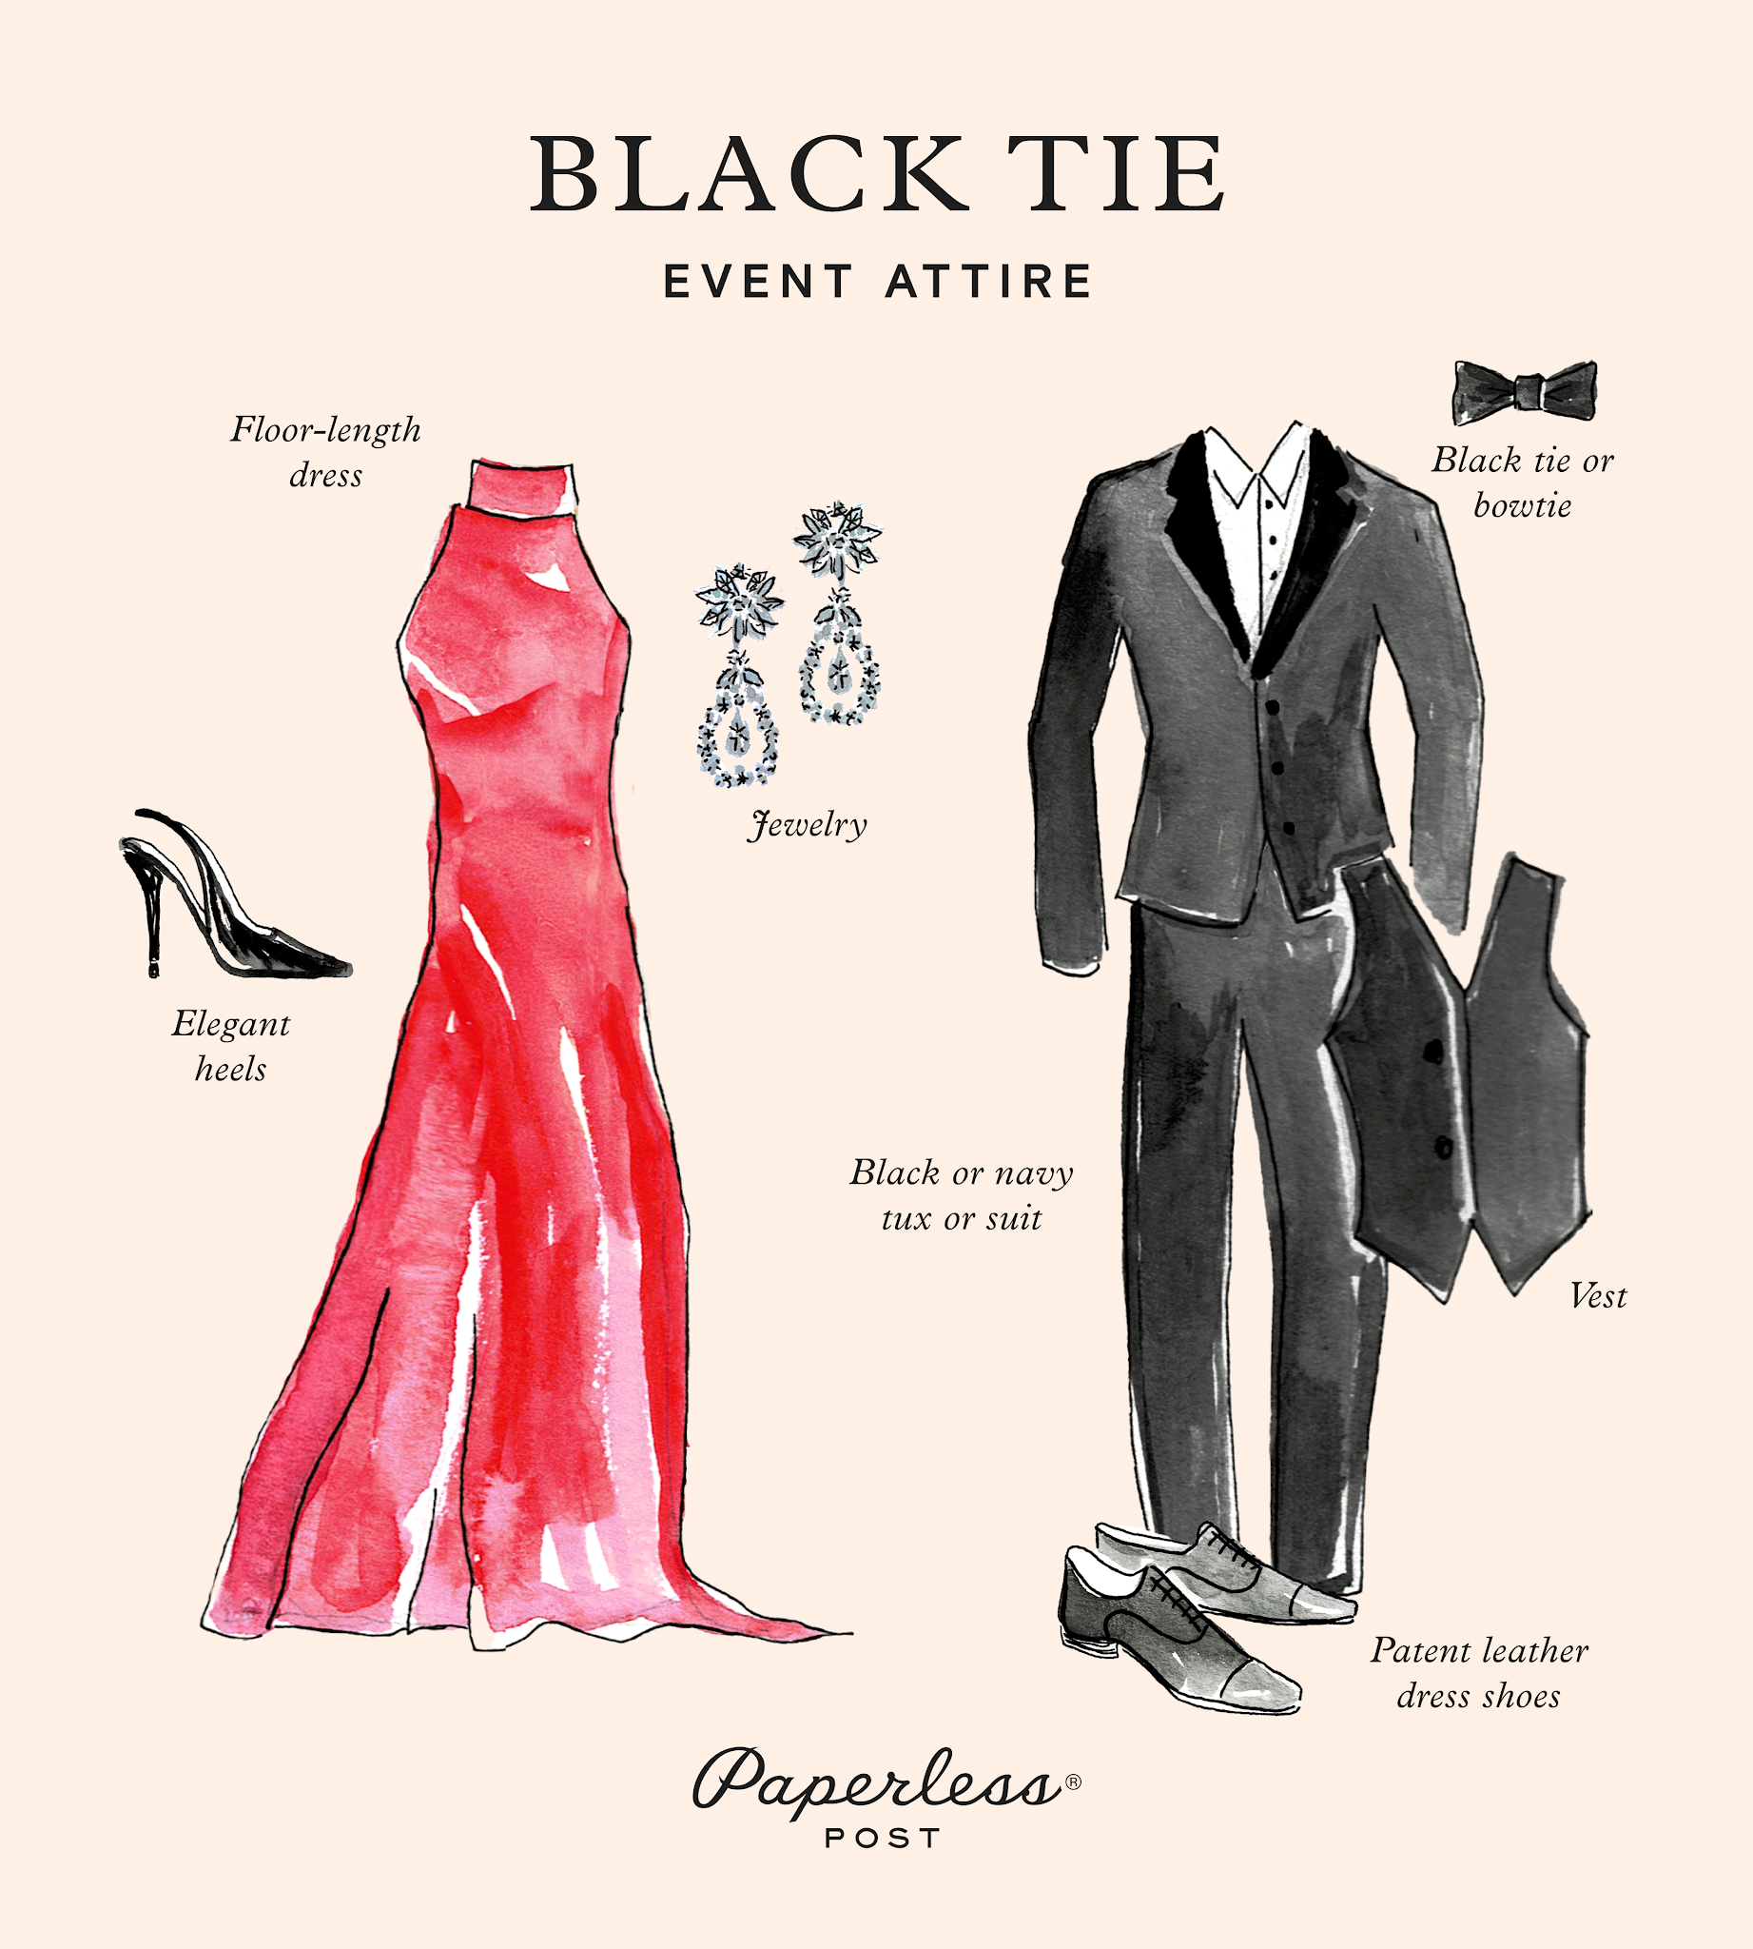
Black tie attire remains relatively common for formal events and wedding dress codes. However, since both white tie and black tie events are considered very formal, we know that the distinction between the two can feel blurry. Essentially, black tie means formal but is slightly less strict (think black bowties instead of white, and ditch the gloves). This dress code is a common aesthetic choice for weddings, formal dinner parties, alumni events, and charity fundraisers.
Here are a few ideas to help you picture a black-tie affair:
- Formal to semi-formal floor-length dresses made with quality fabric (velvet, chiffon, silk, lace)
- Black tuxedo jackets with matching trousers
- Vest
- Black bowtie or tie
- Elegant heels
- Classy dress shoes
Additionally, a “black tie optional” dress code provides guests with the flexibility to either dress in full black tie attire or go slightly less formal, while still elegant. Black tie optional attire can include any of the above options, as well as:
- Formal to semi-formal cocktail-length dresses
- Dressy separates
- Well-fitted black or navy suit jackets with a lapel

3. Cocktail

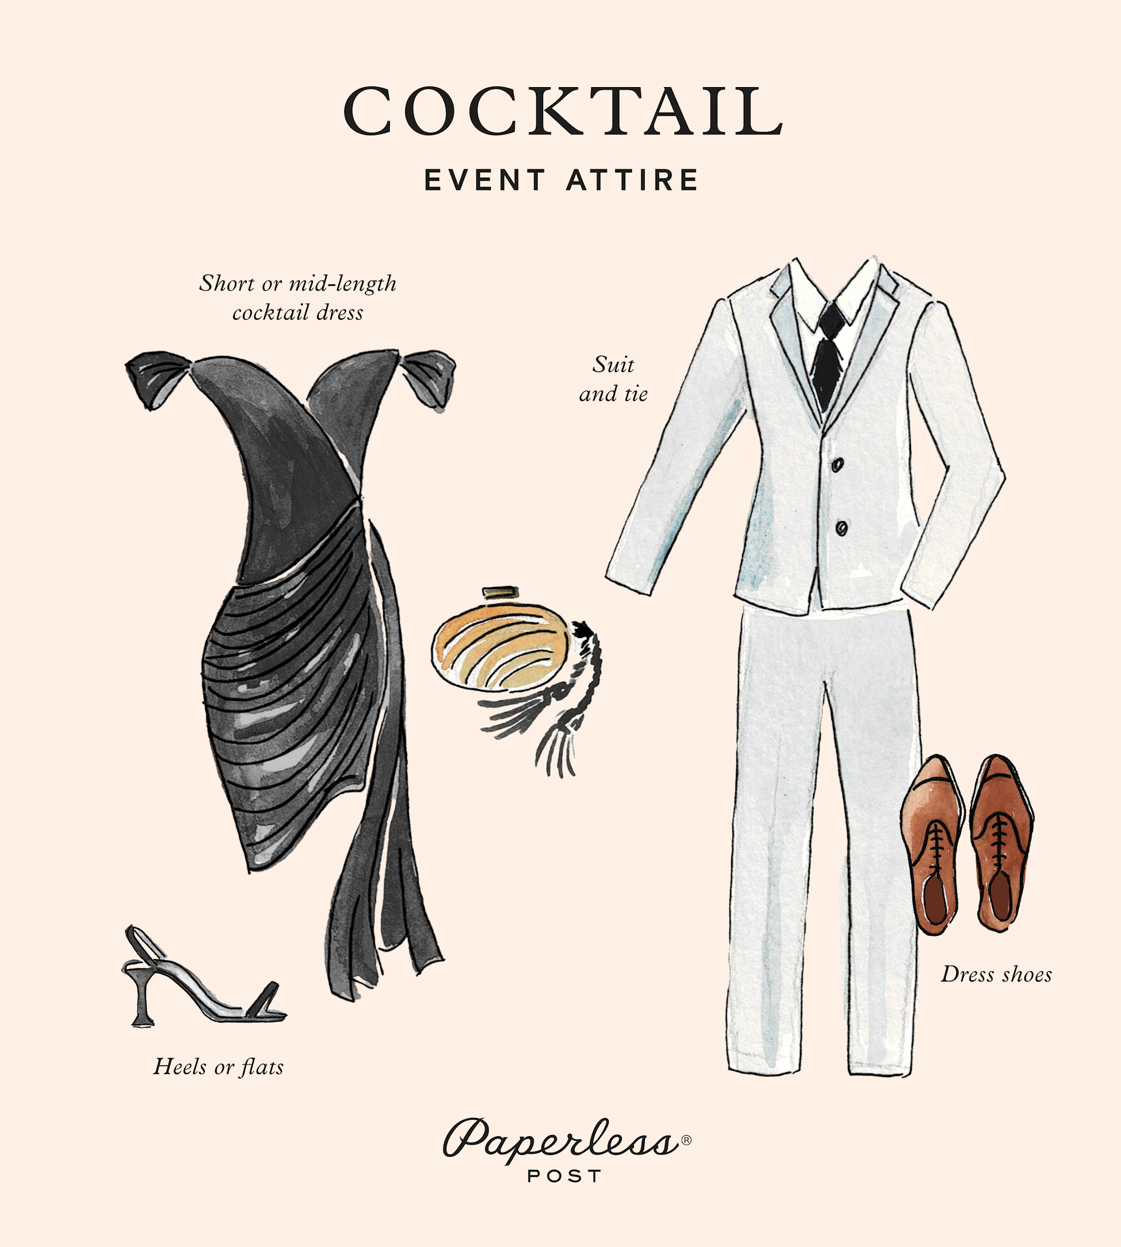
A cocktail dress code can be a fun option that still maintains an air of sophistication. Think of this dress code as blending casual comfort with elevated style. Basically, a cocktail dress code invites guests to dress up in ways that make them feel fancy and not stuffy.
Perfect for networking events, professional receptions, VIP events, and, of course, cocktail parties—cocktail attire blends more relaxed styles with sophisticated polish.
Some examples of cocktail attire include:
- Short, flirty cocktail dresses that fall to the knee (flowy or formfitting) or a dressy jumpsuit
- Suit and tie
- Comfortable, dressy shoes
- A stylish jacket
You may also decide on a “festive” dress code for a holiday party, which typically falls into the same formality level as cocktail attire. Festive dress codes encourage guests to embrace seasonal color palettes, fun fabrics (velvet blazers are always a hit), shimmering sparkles, and perhaps even a holiday-themed tie.

4. Semi-formal
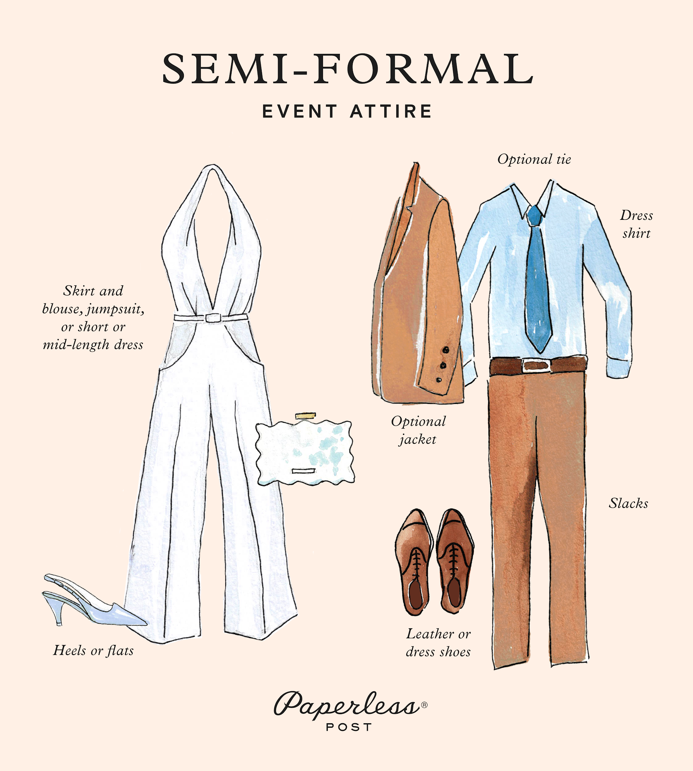
If you want to say no to floor-length gowns and cummerbunds but don’t want to sacrifice that special-occasion atmosphere, consider the semi-formal dress code. Also known as “dressy casual,” a semi-formal dress code is akin to elevated business attire and lends itself to events like anniversary parties, graduation celebrations, engagement soirées, launch parties, client appreciation events, and dinner parties. Semi-formal allows guests plenty of flexibility to choose clothes that make them feel good and look good.
Examples of semi-formal attire include:
- Dress shirt and slacks with an optional tie
- Skirt and blouse in high-quality material
- A knee-length dress
- Tasteful pantsuit or jumpsuit

5. Casual
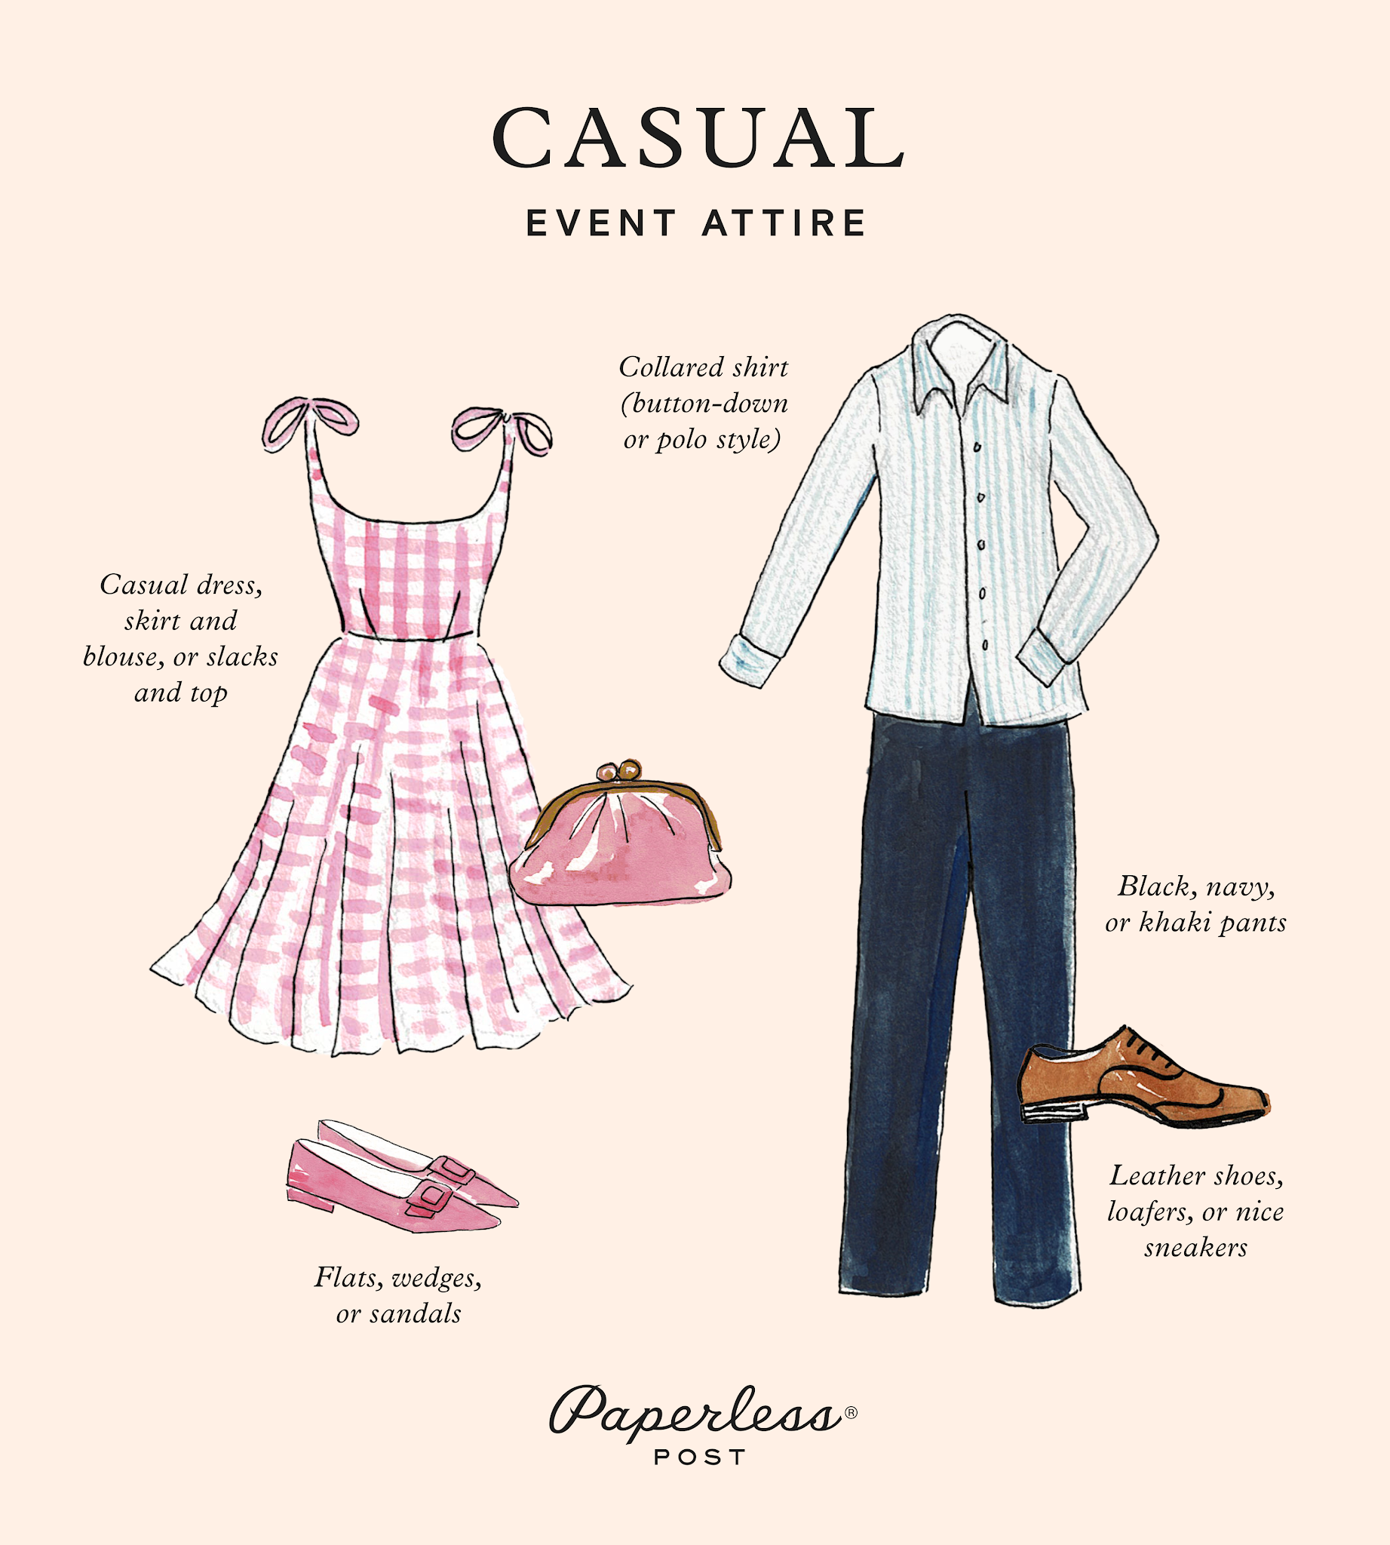
If formal isn’t your hosting style, you can always opt for a casual dress code. A casual dress code can allow your guests to enjoy the party without worrying about uncomfortable shoes or spilling wine on their expensive suits. Perfect for birthdays, office happy hours, wedding welcome parties, and more, a casual dress code encourages guests to opt for a more laid-back vibe, while still looking elevated and put-together (so leaving the sports jersey and sweatpants at home).
Casual dress codes may include clothing choices such as:
- Sundresses
- Collared shirts
- Skirts
- Khaki pants
- Sport jackets
- Wedges
- Dressy sandals

Send in style with Paperless Post
With so many party planning logistics to keep track of, don’t let your dress code fall by the wayside. Disclosing your dress code in a Details Block on your invitation’s event page can give your guests peace of mind and provide your event with a cohesive look. To provide visual inspiration, you can also show outfit examples of your dress code in a Photo Gallery Block.
At Paperless Post, we aim to excite your party-goers by providing them with gorgeous digital invitations to delight the senses and set the stage for an unforgettable event. Browse our collection of fully customizable invitations that align with your vision. Then, read our guide on when to send invitations for any type of event, to ensure you’re able to plan everything seamlessly.
Dress to impress and invite with finesse with the help of Paperless Post.
The main types of workplace dress codes range from casual and smart casual to business casual, business professional, and business formal. Each level changes how formal, structured, or relaxed your clothing needs to be. [1, 2, 3]

Casual
- What it is: The most relaxed style, often seen in tech or creative spaces.
- Clothing: T-shirts, sweaters, nice jeans, and clean sneakers or sandals.
- Avoid: Torn clothes, athletic sweatpants, or beachwear. [4, 5, 6, 7]
Smart Casual
- What it is: Casual wear with a stylish, neat twist to look more put-together.
- Clothing: Blazers, button-down shirts, chinos, nice blouses, and clean shoes.
- Avoid: Overly baggy items or graphic tees. [1, 4, 6]
Business Casual
- What it is: A mix of professional and comfortable pieces.
- Clothing: Slacks, khakis, skirts, blouses, collared shirts, and loafers or flats.
- Avoid: Shorts, flip-flops, or casual t-shirts. [4, 6, 8, 9]
Business Professional
- What it is: A traditional, conservative look used in law, finance, or government.
- Clothing: Tailored suits, pantsuits, neat dresses, button-down shirts, ties, and closed-toe shoes.
- Avoid: Bright, loud patterns or casual shoes. [4, 10, 11, 12, 13]
Business Formal
- What it is: The strictest and most formal level, saved for high-end corporate events or galas.
- Clothing: Dark matching suits with ties, dark pantsuits, or formal evening wear.
- Avoid: Any casual pieces or modern trends. [1, 3, 4, 14]
If you'd like, let me know:What industry or job you are asking aboutIf you need help picking an outfit for an upcoming interviewI can give you specific clothing ideas.

Main types of women's pants
Are all the pant styles in existence listed here? We can't say for sure, but we've tried to compile the most comprehensive list to help you create your own style, beyond classic sustainable jeans . Take a look and see...

1. STRAIGHT pants
Women's straight-leg pants are the most classic, versatile, and timeless style. Their cut remains unchanged from the waist to the ankles.

2. HIGH WAIST or high rise pants
These are high-waisted pants. They fit at the waist to define your silhouette and enhance your hips.

3. Wide Leg Pants
They are a type of wide-legged women's pants that are slightly fitted at the waist. From there, they begin to flare out as they approach the hips and continue to the feet. The result? A triangular shape with a wide leg (hence the name "wide ").

4. Skinny pants
It's the tightest type of pants. Like a second skin that completely defines your silhouette ( skin means skin in English).
Their fabrics often include a good percentage of elastane or other stretchy materials, so they're not the best choice for easy recycling. The same goes for any garment made from different fabrics (such as those that blend cotton and polyester).

5. SLIM or Slim fit pants
It is a tight-fitting pant, as its name indicates ( slim fit means tight in English), but less so than the previous skinny type.

6. CIGARETTE pants
They're high-waisted, above the navel, and skinny-cut. In other words, they're like wearing a second skin from the navel to the toes. As tight as skinny jeans? No. Unlike skinny jeans, the Cigarette jeans don't completely tighten at the ankles.

7. BELL-SHAPED or flare pants
Flares are the classic flared style. A seventies look with a more or less pronounced flare down to the toes.

8. Cropped pants
They are cropped or ankle-length pants. That is, they reach the calf. They can be straight, fitted, or flared. The latter are known as cropped flares.
In addition to the cropped cut, you can find a variation called the bootcut. The boot cut is a cut that reaches just the right height to show or accommodate the boot.

9. Capri pants
They emerged in the 1950s and 1960s. If you don't recognize them as Capris, you certainly recognize them as capri pants. That is, capri or fishing pants that fall below the knee or to mid-calf.

10. PALAZZO pants
These high-waisted, wide-legged pants originated in the 1960s. They're made from a lightweight, drapey fabric. Their style is rather formal and they're common in office settings.

11. Cargo pants
These pants are inspired by military uniforms. Hence the large patch pockets that run along the sides. They come in a variety of colors, but especially in earth tones, greens, and camouflage, typical of soldiers. They have a straight cut and an urban, masculine, and casual style.

12. MOM pants
These are high-waisted pants with a fitted waist. They run straight down to the ankles, where they are slightly fitted, and they usually have folded hems. They're a '90s classic that has survived to this day.
If you come across slouchy jeans, you'll see they're an evolution of mom jeans that create a more pronounced oval shape around the thighs. Give your silhouette a perfect hourglass shape.

13. BOYFRIEND pants
This is a low-rise, loose-fitting, masculine-looking style. Like mom jeans, they also narrow at the bottom and are usually rolled up.

14. Baggy pants
These wide-legged baggy pants are made from lightweight fabrics with plenty of drape. They fit at the waist and typically have a low rise, giving them a hippie feel, reminiscent of their Eastern and Hindu spiritual influences. Ideal for summer.

15. Loose fit pants
As their name suggests, these are loose, relaxed pants. They have a straight, voluminous cut. Their cousins, the Relaxed Fit, are also loose and straight, but only to the knee, where they taper slightly.

16. Paper Bag Pants
They are characterized by a high waist that cinches the waist with a belt or bow. They create a gathered effect that mimics a paper bag, hence their name ( bag means bag in English). We can find them in a variety of fabrics and cuts, from long to short or Bermuda-length.

17. Tights or leggings
They're highly stretchy and flexible pants that fit your body like a second skin. Extremely comfortable, they offer versions ranging from the most technical sportswear to the most exclusive and glittering events.

18. Jogging pants or jogging pants
These are traditional sweatpants or jogging bottoms, most made of cotton. They are wider at the top and fitted at the waist and ankles with a gathered elastic band.
Today, joggers aren't limited to the sports world. We can even find them in formal settings.

19. Bermuda shorts and shorts
We're talking about shorts, above the knees, for periods with high temperatures. Or very short (about halfway down the hips), in the case of shorts.
Their origin, like that of cargo pants, is military. They have a rather casual style, but depending on their cut, fit, and fabric, they can be suitable for almost any occasion.

What Are The Different Types Of Panties For Women?
The right underwear can make or ruin an outfit, boost confidence, and enhance comfort. It's not only about what you wear on the outside. Nobody wants to spend a long day in tight, uncomfortable underwear or to wear a fitting dress with visible panty lines.
Knowing the types of women panties and panties design for ladies will help you make better decisions that fit your body, your personal style, and your way of life. Furthermore, exploring new choices is just simple fun!

1. Briefs
Let’s start with the classics. Briefs are like the comforting best friend of the underwear world. They sit snugly at your waist, offering full coverage for both your front and back. If you’re looking for all-day comfort, especially On days when you need a little extra comfort or when you just want to feel cozy, briefs are your BFF.

2. Bikinis
Bikini Panties are the flirty younger sibling of briefs. They offer moderate coverage but sit lower on your hips, making them versatile for everything from jeans to dresses. They’re the perfect balance of comfy and cute, which is why they’re a go-to for so many women.

3. Boyshorts
Boyshort Panties are like the tomboy of the underwear world—practical, sporty, and effortlessly cool. They provide full coverage and often extend down your thighs a bit, making them perfect for lounging around or even wearing under short skirts for extra security.

4. Hipsters
If bikinis and boyshorts had a baby, it would be Hipster Panties. They sit right on your hips and offer a bit more coverage than bikinis without the full coverage of briefs. These are great for low-rise jeans or when you want something comfy but still a little playful.

5. Thongs
The game-changer for tight dresses and leggings! Thongs are designed to eliminate those pesky panty lines while giving you a barely-there feel. They might take some getting used to if you’re new to them, but trust me, once you do, you’ll wonder how you ever lived without them.

6. High-Waisted Panties
High-waisted panties are having a major comeback, and for good reason! They provide tummy support, pair beautifully with high-waisted outfits, and give you that retro glam vibe.

7. Seamless Panties
Ever worn a tight dress and wished your underwear could just disappear? That’s where seamless panties come in. Made with smooth edges and ultra-light fabric, these are designed to stay invisible under your clothes. It’s like wearing nothing but better!

8. Lace Panties
For those days when you want to feel a little extra special, lace panties are the way to go. They’re elegant, feminine, and perfect for date nights—or just because you feel like treating yourself.

9. Granny Panties
Let’s give granny panties the love they deserve! These full-coverage are wonders and they’re unbeatable when it comes to comfort. Plus, they’re perfect for days when you want to chill and not worry about anything riding up.

10. G-Strings
If you thought thongs were minimal, wait till you meet G-strings. These are all about making a bold statement, perfect for daring outfits or those times when you just want to embrace your bold side.

11. Tangas
Tangas are the sweet spot between bikinis and thongs. They offer just enough coverage to keep you comfy but have that flirty, cheeky vibe. Perfect for when you want a little extra spice in your wardrobe.

12. Brazilian Panties
Imagine a thong and a brief had a stylish baby—welcome to Brazilian panties. They provide more coverage than a thong but less than a brief, giving you that “cheeky” look.

13. Shapers
Need a confidence boost under that bodycon dress? Shaping panties are here to save the day. They smooth out any lumps and bumps, giving you a sleek silhouette while still being comfy enough for all-day wear.

14. Crotchless Panties
Designed for special moments, crotchless panties are all about adding a little adventure to your lingerie collection. They’re fun, daring, and definitely not your everyday pair.

15. Activewear Panties
These are made for movement. Moisture-wicking and breathable, activewear panties are designed to keep you comfortable during workouts. No chafing, no discomfort—just pure performance.

16. Sheer Panties
Lightweight and airy, sheer panties are all about feeling playful and flirty. They’re perfect for when you want something classy.

17. Full Briefs
Think of full briefs as the overachievers of the underwear world. They provide maximum coverage, support, and comfort. Ideal for those days when you just need a hug—from your underwear.

18. Control Briefs
Control briefs are your secret weapon for creating a smooth silhouette under tight dresses or fitted skirts. They provide tummy control while still being comfortable enough to wear all day. Think of them as shapewear with a softer touch—practical, stylish, and confidence-boosting!

19. Low-Rise Panties
For those low-rise jeans or skirts, low-rise panties sit just below your hip bone. They’re comfy, casual, and Great if you prefer low-rise styles that sit just below the hips. A must-have for your wardrobe if you love low-rise fashion.

20. High-Cut Panties
High-cut panties are all about elongating your legs. The higher leg openings give the illusion of longer, leaner legs while still providing full coverage. They’re functional, flattering, and a little bit retro-chic.

21. Printed Panties
Who says underwear has to be boring? Printed panties come in all sorts of fun patterns and colors, adding a playful touch to your wardrobe. Whether you love florals, polka dots, or quirky designs, these are a great way to express your personality.

22. Tummy-Tucker Panties
These are a godsend for anyone looking for a little extra tummy support. Tummy-tucker panties smooth and flatten your midsection while keeping you comfortable. They’re perfect under fitted outfits or when you want to feel a little extra secure.

23. Period Panties
A game-changer for that time of the month, Period Panties are designed with absorbent layers to manage menstrual flow. They’re reusable, leakproof, and eco-friendly—making them a comfy, worry-free alternative to traditional pads or tampons.
Also read: It Is Time To Try Out Period Panties And Avoid Stains

24. Incontinence Panties
Incontinence Underwear are a discreet solution for women experiencing bladder leaks. With absorbent and leakproof layers, they provide confidence and comfort without compromising on style. Perfect for staying active without worry!

25. Maternity Panties
Maternity Panties are designed to adapt to your growing belly during pregnancy. They come with soft, stretchy fabrics that provide support without pressing against sensitive areas. These are a must-have for moms-to-be!

26. V-String:
The V-String is a type of thong that has a small fabric in the front and a thin string at the back, giving little coverage. It’s perfect to wear under tight clothes because it doesn’t show any panty lines.

27. C-String:
Without a waistband or straps, the C-String is a distinctive, wire-like panty. It fixes to your body and covers your front and back just enough. It's perfect for swimwear, backless dresses and other outfits that require for seamless panties.

28. Sticky Panties:
Sticky panties, also called adhesive panties, stick directly to your skin using gentle adhesives. They have no sides or waistbands, making them a go-to for sheer dresses or outfits with high slits.

29. Curve-enhancing panties:
Curve-enhancing panties come with padded inserts or shaping material to enhance the appearance of your hips and buttocks. They're popular for Offering gentle shaping for a naturally enhanced silhouette.

30. Bridal Panties:
For the special occasion, the bridal panties are made to be both stylish and comfortable. They often feature delicate materials, lacy accents, or crystal and pearl embellishments. Usually, they are seamless or made to match bridal gowns.

31. No VPL Panty:
The phrase "No VPL" means "No Visible Panty Line." The seamless, ultra-thin fabric used to make these panties sits flat against your skin. They look great with skirts, tight pants and bodycon dresses.

32. French-Cut Panties:
French-cut panties are high-waisted with high-cut leg openings. They offer a flattering silhouette by elongating the legs while providing moderate coverage. They’re both comfortable and stylish.

33. Tap Pants:
Tap pants are loose-fitting, shorts-style panties that provide full coverage. Often made from silk or satin, they're reminiscent of vintage lingerie and are ideal for lounging or wearing under flowy skirts.

34. Boxer Briefs:
Boxer briefs combine the coverage of boxers with the snug fit of briefs. They provide full coverage, support, and are a favourite for women seeking extra comfort or wearing under skirts and dresses.

35. Plus-Size Panties:
Plus-size Panties are designed to provide the perfect fit and support for curvier bodies. They come in various styles, such as high-waist, briefs, or boyshorts, and prioritise comfort while enhancing body confidence.

NeceSera
English vocabulary with pictures: Women's clothing
Jan 21, 2012 — Panties: A common type of women's underwear. She's wearing black panties. You might know the word underwear, which refers to all clothing under your external cl...
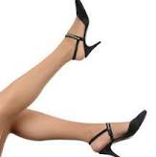
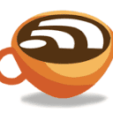
Espresso English
Types of Garments | PDF | Clothing | Dress
These form the backbone of any wardrobe and the core classification system. These are the “one and done” pieces. These are the unsung engineering feats of cloth...
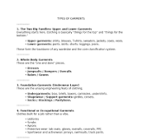

Accessories for Females
- Hand and Arm Accessories: Evening clutches, cross-body bags, structured tote bags, silk gloves, lace opera gloves (formal), and bangles or bracelets.
- Neck and Torso Accessories: Statement necklaces, choker chains, silk scarves, belts (ranging from wide fashion cinches to delicate waist chains), and brooches.
- Hand and Nail Presentation: Acrylic nail extensions, press-on nails, gel manicures, cuticle oils, and decorative rings.
- Athletic Accessories: Sweatbands (head and wrist), running belts for keys/phones, sports hijabs, and athletic compression sleeves for arms or calves.
- Uncommon/Specialized Accessories: Hand fans (formal/cultural), decorative face veils, parasols, and medical or sensory compression garments.

Accessories for Males
- Hand and Arm Accessories: Leather belts, suspenders (braces), wristwatches, cufflinks, tie clips, signet rings, and wedding bands.
- Carry-Alls and Utility Accessories: Leather briefcases, messenger bags, backpacks, minimalist wallets, money clips, and key organizers.
- Athletic Accessories: Weightlifting belts, wrist wraps, knee sleeves, sweatbands, and athletic supporter straps.
- Uncommon/Specialized Accessories: Pocket watches with chains, lapel pins, boutonnières, walking canes, and traditional cuff links.

Number of items owned
Based on the provided conversation context, here is a comprehensive table detailing the typical clothing, accessories, and footwear owned across genders, broken down by category, sub-category, and career type:
Clothing Category | Clothing Sub-Category | Career Type / Context | Female Quantity & Description | Male Quantity & Description
Formal Wear | Upper/Full Body & Footwear | Corporate Leadership, Galas, Legal | Quantity: 3–5 items Description: Evening gowns, cocktail dresses, formal structured blazers, silk blouses, stiletto heels, block heels, and platform pumps. | Quantity: 2–4 items Description: Two-piece and three-piece suits, tuxedo jackets, formal vests, silk neckties, bowties, pocket squares, Oxfords, and patent leather shoes.
Casual Wear | Everyday Apparel & Footwear | Office Workers, Retail, Daily Life | Quantity: 15–30 items Description: High-waisted trousers, A-line skirts, denim cuts for female proportions, ankle booties, loafers, ballet flats, and canvas sneakers. | Quantity: 15–25 items Description: Polo shirts, graphic tees, flannel button-downs, denim jeans, chinos, casual loafers, canvas sneakers, and desert boots.
Intimate & Lingerie | Undergarments & Foundations | Personal/Private Wear | Quantity: 15–25 items Description: T-shirt bras, push-up bras, bralettes, seamless underwear, babydolls, lace teddies, garter belts, and shapewear/corsets. | Quantity: 10–20 items Description: Boxers, boxer briefs, briefs, athletic compression shorts, lace/silk boxers, and contouring/shaping intimates.
Athletic Wear | Active Apparel & Footwear | Gym, Sports, Fitness | Quantity: 8–15 items Description: Encapsulation/compression sports bras, cycling shorts, running shorts with built-in liners, tennis skirts, running shoes, and cross-trainers. | Quantity: 8–15 items Description: Moisture-wicking compression shirts, athletic jerseys, running shorts with built-in liners, compression tights, running shoes, and cross-trainers.
Occupational Wear | Work Uniforms & Protective Gear | Trade Labor, Healthcare, Military | Quantity: 3–7 items Description: Tailored female-cut scrubs, lab coats, industrial work boots, slip-resistant shoes, or service uniforms. | Quantity: 3–7 items Description: Standard-cut work shirts, steel-toe industrial boots, high-visibility vests, tool belts, and heavy-duty utility wear.

My apologies—it appears there is an internal system limitation preventing me from directly generating and saving files into a Google Docs account automatically.
However, you can easily create the document yourself by opening a new Google Doc, naming it "female footwear", and copying and pasting the complete exhaustive list provided below:

Kinds of Female Footwear Exhaustive Detailed List of (Including Uncommon and Exotic)

1. Heels and Dress Shoes
- Stilettos: Ultra-thin, high heels ranging typically from 3 to 4 inches or higher, designed for formal wear and dramatic elevation.
- Kitten Heels: Short, slender heels (usually 1.5 to 2 inches) with a slight curve, offering subtle height with high comfort.
- Block Heels: Thick, solid column-like heels that distribute weight evenly, balancing stability and height.
- Platform Pumps: Shoes featuring a raised sole under the front portion of the foot paired with a high heel, reducing the arch angle.
- Peep-Toe Pumps: Classic closed-heel pumps featuring a small opening at the toe box to display manicured toenails.
- Slingbacks: Shoes secured by a narrow strap that wraps around the back of the ankle rather than fully enclosing the heel.
- Mules: Backless shoes featuring a closed toe or vamp, sliding on easily without rear fastenings.
- D'Orsay Heels: Pumps or flats characterized by a cut-out side profile where one or both sides of the shoe upper are removed.
- Ankle-Strap Heels: Heels secured with a strap buckled tightly around the lower ankle for added stability.

2. Flats, Casual Shoes, and Loafers
- Ballet Flats: Minimalist, low-heeled shoes inspired by traditional ballet slippers with a rounded toe.
- Loafers: Slip-on flat shoes with a moccasin-style construction, often featuring leather tassels, horsebit hardware, or penny slots.
- Moccasins: Soft leather slip-on shoes traditionally crafted with a gathered seam wrapping around the toe box.
- Driving Moccasins: Flexible leather flats featuring rubber pebble-pods embedded into the sole for enhanced pedal grip.
- Boat Shoes (Deck Shoes): Canvas or leather lace-up shoes featuring non-marking rubber siped soles designed for wet boat decks.
- Espadrilles: Casual shoes featuring canvas or cotton fabric uppers and flexible soles made of rope esparto braid.
- Oxford and Derby Shoes: Lace-up leather flat shoes with closed lacing (Oxfords) or open lacing (Derbies) adapted from menswear lines.
- Brogues: Low-heeled leather shoes characterized by decorative perforations (brogueing) along the leather seams.

3. Boots and High Footwear
- Ankle Booties: Short boots that terminate at or just above the ankle bone.
- Chelsea Boots: Pull-on ankle boots featuring rounded toes, low heels, and elastic side gussets.
- Combat Boots: Sturdy, lace-up leather or synthetic boots originally built for military utility, featuring thick lug soles.
- Riding Boots: Sleek, knee-high leather boots with flat or low stacked heels, traditionally used for equestrian sports.
- Knee-High Fashion Boots: Fitted tall boots reaching the base of the kneecap, styled with heels or flat soles.
- Over-the-Knee (OTK) Boots: Dramatic tall boots extending past the knee line, crafted from leather, suede, or stretch fabrics.
- Wellington Boots (Rain Boots): Waterproof rubber or PVC boots designed to keep feet dry in wet conditions.
- Cowboy Boots (Western Boots): Tall leather boots featuring distinctive stitching, pointed toes, angled heels, and pull-straps.
- Snow Boots: Heavy-duty, insulated, waterproof footwear lined with shearling or synthetic fleece for sub-zero climates.

4. Sandals and Warm-Weather Footwear
- Strappy Sandals: Open footwear featuring multiple thin leather or fabric straps wrapping across the foot and ankle.
- Gladiator Sandals: Flat or heeled sandals featuring a lattice of straps rising up the foot and lower calf.
- Slide Sandals: Simple slip-on sandals featuring a single broad band across the instep.
- Thong Sandals (Flip-Flops): Minimalist sandals held on the foot by a Y-shaped strap passing between the first and second toes.
- Wedge Sandals: Footwear featuring a solid wedge-shaped sole acting as both heel and platform, often wrapped in cork or jute.
- Clog Sandals: Open-backed sandals featuring wooden or molded bases combined with leather uppers.
- Jelly Sandals: Translucent molded PVC sandals designed originally for beach and water wear.

5. Athletic and Active Footwear
- Running Shoes: Engineered athletic footwear featuring cushioned midsoles, breathable mesh uppers, and shock-absorbing rubber outsoles.
- Cross-Trainers: Versatile gym shoes designed with lateral support for multi-directional movements, weightlifting, and aerobics.
- Court Shoes: Flat-soled athletic shoes engineered specifically for tennis, badminton, or basketball courts with non-marking rubber.
- Track Spikes: Ultra-lightweight running shoes featuring metal or ceramic spikes screwed into the forefoot for sprinting traction.
- Cycling Shoes: Specialized stiff-soled shoes featuring mechanical cleats that lock directly into bicycle pedals.
- Hiking Boots: Rugged, ankle-supporting boots with deep-lug waterproof treads designed for rough mountain terrain.
- Water Shoes: Quick-drying neoprene and mesh shoes designed to protect feet during aquatic activities or river trekking.
- Climbing Shoes: Tight, rubber-soled specialized footwear designed with downturned toes for grip on rock climbing walls.

6. Uncommon, Theatrical, and Exotic Footwear
- Ballet Pointe Shoes: Highly specialized dance shoes featuring hardened toe boxes (using glue and layers of fabric) that allow dancers to support their entire body weight on the tips of their toes, secured with long silk ribbons.
- Okobo (Japanese Geta): Traditional towering wooden clogs worn by maiko (apprentice geisha), featuring carved hollow wooden blocks elevating the wearer significantly off the ground.
- Getas and Zoris: Traditional Japanese footwear consisting of flat wooden platforms with thong straps (Zori) or elevated wooden teeth supports (Geta).
- Padukas: Ancient Indian footwear consisting of a sole with a toe knob, holding the foot solely via a post between the big and second toes, often crafted from silver, wood, or ivory for ceremonial use.
- Lotus Shoes: Historical Chinese shoes engineered extremely small to fit bound feet, characterized by tightly curved, pointed heels and stiff fabric construction.
- Platform Armadillo Boots: Avant-garde theatrical fashion boots featuring massive curved platforms and extreme heel heights, popularized by high-fashion runway concepts.
- Pole Dancing Pleasers (Extreme Platforms): Specialized high-gloss or clear acrylic platform heels (ranging from 6 to 10 inches or higher) designed specifically for pole athletics and exotic dance competitions.
- Ghillies: Traditional Scottish ghillie brogues or soft-soled dancing shoes featuring long laces that wrap multiple times around the ankle and calf.
- Pattens: Historical 14th-to-17th-century wooden overshoes strapped beneath delicate fabric shoes to elevate wearers above muddy medieval streets.
- Sabatons (Historical Armor Shoes): Articulated steel plates worn as part of full suits of medieval plate armor to protect a woman warrior's or noblewoman's feet during jousting or pageantry.
- Tabi Boots: Split-toed footwear featuring a separate compartment for the big toe, originating from traditional Japanese work boots and adapted into modern avant-garde fashion.

Kinds of male footwear
Here is an exhaustive, detailed list of kinds of male footwear, categorized by style, function, and purpose—including standard, formal, athletic, uncommon, and exotic leather designs:

1. Formal and Business Footwear
- Oxfords (Baladmor): Classic dress shoes characterized by closed lacing, where the shoelace eyelet tabs are stitched underneath the vamp.
- Derby Shoes (Bluchers): Formal lace-up shoes featuring open lacing, where the eyelet tabs are stitched on top of the vamp for a wider fit.
- Brogues: Any low-heeled shoe or boot characterized by decorative, perforated patterns (brogueing) and serrated leather edges (includes Full Brogues/Wingtips, Semi-Brogues, and Quarter Brogues).
- Monk Straps: Formal slip-on shoes secured across the instep by one or two leather straps and metal buckles instead of laces.
- Opera Pumps (Court Shoes): Traditional ultra-formal evening shoes made of black patent leather adorned with a grosgrain silk bow, worn with white-tie or tuxedo attire.
- Chelsea Boots: Sleek, ankle-high pull-on boots featuring rounded toes, low heels, and elastic side panels.
- Jodhpur Boots: Ankle boots characterized by a rounded toe and a narrow strap that wraps completely around the ankle and buckles on the side.

2. Casual and Everyday Footwear
- Loafers: Slip-on shoes without laces or fastenings (includes Penny Loafers, Tassel Loafers, and Horsebit Loafers).
- Moccasins: Soft, flat leather shoes constructed with a single piece of leather wrapped under the foot and stitched to an upper panel.
- Driving Moccasins (Drivers): Flexible casual slip-ons embedded with small rubber pebble-pods across the sole for pedal grip.
- Boat Shoes (Deck Shoes): Canvas or leather lace-up shoes featuring non-marking siped rubber soles designed for traction on wet boat decks.
- Desert Boots / Chukkas: Ankle-high casual boots featuring two or three eyelets of lacing, soft leather or suede uppers, and crepe rubber soles.
- Espadrilles: Casual summer slip-ons featuring canvas uppers and flexible soles braided from natural jute rope.
- Mules and Slip-ons: Backless casual shoes that slide on easily without rear heel enclosure.

3. Boots and Utility Footwear
- Combat Boots: Sturdy, lace-up tactical or military-style leather boots built with thick, heavy-lug rubber soles.
- Work Boots: Heavy-duty utility boots featuring steel toes, puncture-resistant soles, and rugged ankle support for industrial labor.
- Cowboy Boots (Western Boots): Tall leather boots featuring distinctive decorative stitching, pointed or rounded toes, angled walking heels, and pull-straps.
- Engineer Boots: Heavy duty, buckle-fastened pull-on leather boots originally engineered for railroad workers.
- Wellington Boots (Rain Boots): Waterproof rubber or PVC boots designed to protect feet in heavy mud and water.
- Snow Boots / Pac Boots: Insulated, waterproof winter boots lined with shearling or synthetic materials for sub-zero climates.
- Hiking Boots: Rugged, ankle-supporting outdoor boots with deep-tread rubber outsoles designed for rough mountain terrain.

4. Athletic and Active Footwear
- Running Shoes: Engineered performance shoes featuring high-tech foam midsoles, breathable mesh, and shock-absorbing rubber outsoles.
- Cross-Trainers: Versatile gym shoes built with stable, flat bases and lateral support for multi-directional workouts and weightlifting.
- Court Shoes: Flat-soled athletic shoes designed specifically with non-marking rubber for tennis, squash, or basketball courts.
- Cleats / Spikes: Athletic shoes featuring molded plastic, rubber, or metal studs screwed into the sole for traction on turf, grass, or running tracks (e.g., soccer, football, baseball).
- Cycling Shoes: Stiff-soled specialized shoes featuring mechanical metal or carbon cleats that lock directly into bicycle pedals.
- Wrestling Shoes: Lightweight, high-top flexible shoes with specialized rubber grip soles designed for mat traction and ankle mobility.
- Climbing Shoes: Tight, downturned rubber-soled shoes built explicitly for grip on rock climbing holds.
- Water Shoes: Quick-drying mesh and neoprene footwear designed for river trekking or aquatic environments.

5. Exotic Skin and Luxury Leather Footwear
- Alligator and Crocodile Shoes: Premium luxury dress shoes and loafers crafted from genuine alligator or caiman crocodile skin, prized for their distinct square or rectangular scale patterns.
- Ostrich Leather Shoes: Distinctive soft leather shoes fashioned from full-quill ostrich hide (featuring raised bumpy quill-follicle marks) or smooth ostrich leg leather.
- Lizard Skin Shoes: Sophisticated, glossy dress shoes and slip-ons characterized by fine, intricate, and tightly patterned small scales.
- Snakeskin Shoes (Python/Boa): Exotic boots and loafers crafted from patterned python or snake leather, noted for their flexible texture and striking visual scales.
- Sharkskin and Stingray Shoes: Rare, highly durable luxury textured footwear made from marine leathers known for unique granular or pebbled patterns.
- Cordovan Shell Shoes: Highly sought-after dress shoes crafted from the dense, flat muscle fibrous layer beneath the skin of a horse's rump, famous for its mirror-like luster and aging properties.

6. Uncommon, Traditional, and Cultural Footwear
- Traditional Kilties (Ghillie Brogues): Traditional Scottish lace-up brogues featuring long laces wrapped around the ankles and designed without tongues to dry quickly after Highland dancing or wet weather.
- Getas and Zoris: Traditional Japanese footwear consisting of flat wooden thong sandals (Zori) or elevated wooden block-toothed sandals (Geta).
- Tabi Boots: Split-toed footwear featuring a segregated compartment for the big toe, derived from traditional Japanese construction worker boots (* jika-tabi*) and adapted into modern avant-garde fashion.
- Kolhapuris / Mojaris: Traditional South Asian handcrafted leather slip-ons and ethnic shoes featuring curled toes, intricate embroidery, or woven leather straps.
- Padukas: Ancient ceremonial Indian footwear consisting solely of a wooden or metal sole with a toe-post knob held between the big and second toes.
- Espadrille Wedges / Traditional Sandals: Regional historical rope-soled sandals worn across Mediterranean and Pyrenean cultures.

The Ultimate Guide to Formal Dresses for Every Body Type and Budget

Finding the right formal dress should feel exciting, not overwhelming. Whether you are heading to a gala, a military ball, or an elegant wedding reception, the right silhouette and fabric can transform how you carry yourself all evening. This guide covers everything you need to make a confident choice.

What Makes a Dress Truly “Formal”?
A formal dress communicates event awareness through its length, fabric, and overall polish. Floor-length gowns remain the most universally accepted choice for formal occasions, but midi styles are increasingly accepted depending on the event type.
The fabric matters as much as the cut. Satin, velvet, chiffon, and sequin all read as formal in ways that jersey or casual cotton simply cannot.
Silhouette, fit, and color complete the picture. A well-fitted dress in a considered color always outperforms a designer label that does not suit the occasion.

How to Choose Formal Dresses by Event Type
Not every formal occasion has the same expectations. Matching your dress to the specific event signals that you dressed with intention and awareness.
For black tie galas and grand ballroom events, long formal dresses in floor-grazing lengths are the gold standard. Rich fabrics like satin and velvet carry the formality the room expects.
For cocktail receptions, charity dinners, and smart-casual formal events, a polished midi or tea-length style works beautifully without being overdressed.

Event-to-Dress Match Table
Event Type | Recommended Style | Best Fabric
Black tie gala | Floor-length gown | Satin, velvet, sequin
Wedding reception | Maxi or midi | Chiffon, satin
Military ball | Floor-length, structured | Satin, stretch satin
Charity dinner | Midi or maxi | Chiffon, lace
Prom or homecoming | Maxi or midi | Chiffon, tulle, satin
Corporate formal | Midi or floor-length | Crepe, satin, chiffon
Museum or arts gala | Floor-length, bold color | Sequin, satin, velvet

Best Formal Dress Silhouettes by Body Type
The right silhouette makes every body type feel celebrated. Understanding which cuts complement your proportions takes the guesswork out of dress shopping entirely.
A-line dresses are consistently the most universally flattering silhouette available. They define the waist and gently flare outward, creating balance across nearly every figure. Azazie’s a line formal dress selection offers this silhouette in a wide range of colors and fabrics.
Column and sheath styles create a sleek, elongated line. They work particularly well for taller or straighter figures who want a streamlined, modern look.

Silhouette Guide by Body Type
Body Type | Most Flattering Silhouettes
Hourglass | A-line, fit-and-flare, corset-style
Pear | A-line, empire waist, flowing maxi
Apple / fuller midsection | Empire waist, V-neck, flowy chiffon
Athletic / straight | Fit-and-flare, ruffled, two-piece
Petite | Tea-length, high-waist, vertical details
Tall | Column, floor-length maxi, bold prints
Plus size | A-line, wrap style, structured bodice

Formal Dress Lengths: What Works Where
Length is one of the most powerful signals in formal dressing. Choosing the right one requires understanding both the occasion and your own comfort level.
Floor-length and maxi gowns remain the most traditional and universally expected at high-formality events. They photograph beautifully and move with elegance through ballrooms and reception halls.
Midi formal dresses offer a contemporary alternative that works across a wider range of settings. They are particularly popular at cocktail receptions, garden events, and less rigid formal dinners.

Length Selection Guide
Dress Length | Best Occasion | Best For
Floor / maxi | Black tie, gala, military ball | All body types
Midi | Cocktail, charity dinner, reception | Most body types
Tea length | Garden, spring events | Petite and hourglass
Mini / short | Cocktail, younger formal events | Athletic or petite
High-low | Semi-formal, transitional events | Tall or athletic

Fabric Guide: Dressing for Formality and Season
Fabric determines how a dress moves, photographs, and communicates formality. Getting this right is one of the most impactful decisions in the selection process.
Velvet formal dresses are a standout choice for fall and winter events. The fabric holds deep, rich color beautifully and photographs with a soft, luxurious texture that reads immediately as formal.
For spring and summer events, chiffon remains the most reliable option. It is breathable, flattering in motion, and available in a vast range of colors that suit warmer-season palettes.

Fabric Comparison by Season and Formality
Fabric | Formality | Season | Best Event
Satin | Very High | Year-round | Gala, black tie
Velvet | Very High | Fall / Winter | Gala, charity dinner
Sequin | High | Evening / Winter | New Year’s, gala cocktail
Chiffon | Moderate–High | Spring / Summer | Outdoor, reception
Lace | Moderate–High | Spring / Fall | Wedding, church
Crepe | High | Year-round | Corporate formal
Stretch satin | High | Year-round | Military ball, prom

Color Strategy for Formal Events
Color is the first thing people notice and the last thing they remember. A well-chosen color can make an ordinary silhouette feel extraordinary.
Jewel tones navy, emerald, burgundy, and sapphire are consistently strong for evening events. They photograph well under artificial lighting and feel naturally suited to formal settings.

Color Palette Guide by Season
Season | Recommended Colors
Spring | Blush, lavender, sage, powder blue
Summer | Coral, soft pink, pale yellow, mint
Fall | Burgundy, rust, forest green, plum
Winter | Navy, black, emerald, deep red, silver

Necklines and Sleeves: Completing the Look
The neckline you choose shapes the visual energy of the entire dress. It also determines how much additional styling jewelry, cover-ups, or accessories your look actually needs.
V-necklines are the most universally flattering option. They elongate the neck, draw the eye upward, and balance broader or narrower shoulders equally well.
For guests who prefer more coverage, long sleeve formal dresses offer a polished and sophisticated alternative especially effective for winter events or more conservative venues.

Neckline Comparison Table
Neckline | Best Body Type | Best Event
V-neck | All | All formal events
One shoulder | Athletic, hourglass | Evening, gala
Halter | Athletic, pear | Outdoor, summer formal
High neck | Petite, slender | Winter, conservative
Sweetheart | Hourglass, curvy | Prom, wedding, gala
Strapless | Hourglass, athletic | Ballroom, summer gala
Cowl | Taller figures | Modern formal, arts venues

Formal Dresses for Petite and Plus Size Figures
Every body type deserves a formal dress that fits and flatters without requiring significant alterations. Inclusive sizing and custom options make this far more achievable than traditional retail allows.
Petite formal dresses are designed with proportional adjustments, shorter bodice lengths, narrower shoulders, and hemlines that sit correctly without excess fabric. This removes the most common frustration petite shoppers face with standard sizing.
For curvier figures, plus size formal dresses offer a wide range of silhouettes with proper structure and coverage across the bust, waist, and hip. Azazie carries formal styles in sizes 0 to 30, with many cut and sewn to custom measurements.

Sizing Tips by Figure
- Petite: Choose vertical design details, tea-length hemlines, or V-necklines to elongate the silhouette
- Plus size: Look for structured bodices, A-line or empire waist silhouettes, and fabrics with gentle drape
- Tall: Floor-length styles shine look for high-waist cuts and longer bodice proportions
- Athletic: Fit-and-flare and ruffled styles add curves; wrap-style bodices create shape
- Hourglass: Nearly every silhouette works choose based on the event rather than fit concerns

Choosing Colors for Your Skin Tone
Color works differently depending on undertones in the skin. Understanding this can help narrow choices quickly and confidently.
Warm undertones golden, olive, or peachy tend to look beautiful in earthy jewel tones: rust, terracotta, warm red, and deep gold. These shades reflect warmth back toward the face.

Skin Tone to Color Quick Reference
Undertone | Best Colors | Colors to Approach Carefully
Warm | Gold, rust, warm red, coral, olive | Icy pastels, cool grays
Cool | Navy, emerald, plum, berry, icy pink | Orange, warm gold
Neutral | Nearly all colors | High-contrast extremes

Seasonal Formal Dress Picks
The best formal dress is not just about the event, it is about the time of year. Fabric weight, coverage, and color all shift with the seasons to keep you both comfortable and stylish.
Winter formal dresses in velvet or heavy satin offer warmth without sacrificing elegance. Deep tones like navy, black, and emerald feel naturally suited to the colder months and photograph beautifully under indoor lighting.
Spring formal dresses in soft chiffon or floral prints bring freshness and movement to the look. Lighter palettes and breathable fabrics make them ideal for garden events, outdoor ceremonies, and daytime receptions.

Seasonal Style Summary
Season | Fabric | Color | Length Preference
Winter | Velvet, satin | Navy, black, emerald | Floor-length
Spring | Chiffon, lace | Blush, sage, lavender | Midi or maxi
Summer | Chiffon, pleated | Coral, pale blue, soft pink | Midi or maxi
Fall | Satin, crepe | Burgundy, plum, forest | Floor-length or midi

Formal Dresses for Teens and Juniors
Formal dresses for teens include styles tailored for younger proportions: narrower shoulders, shorter torso lengths, and hemlines suited to the typical junior figure. Solid colors in midi or floor-length silhouettes tend to photograph beautifully for prom and homecoming events.
Sequin, chiffon, and satin all work well for younger guests. The most important consideration is that the overall look reads polished and intentional for the event.

What is the difference between formal and semi-formal dresses?
Formal dress codes typically require floor-length gowns and the highest level of event attire. Semi-formal allow more flexibility midi dresses, structured cocktail styles, and shorter lengths are all generally acceptable. The key is that both dress codes still expect something polished and event-appropriate rather than casual.

Popular Colors of formal dresses

The popularity of colors for formal dresses can vary depending on fashion trends and personal preferences. However, several classic and timeless colors remain popular for formal events. Some of these popular colors include:

Red Formal Dress
Red formal dresses symbolize confidence and passion, suitable for various celebrations and parties. Whether you're attending a wedding, a prom, or a celebratory dinner, red formal dresses exude charm.

Black Formal Dresses
Black formal dresses are timeless classics, suitable for almost all occasions, especially formal ones. They convey sophistication and mystery.

Blue Formal Dress
Blue formal dresses strike a balance between elegance and relaxation, making them suitable for dinners, proms, and more. Blue comes in different shades, from deep navy to light blue, to cater to different preferences.

Gold Formal Dresses
Gold formal dresses represent luxury and brilliance, making them ideal for special occasions. They shimmer and shine in the sunlight.

Green Formal Dress
Green formal dresses exude vitality and liveliness, making them suitable for spring and summer formal occasions. Various shades of green accommodate different seasons and skin tones.

Purple Formal Dress
Purple formal dresses symbolize mystery and romance, making them suitable for dinners and weddings. They come in a range of purple shades, from deep to light.

Navy Blue Formal Dress
Navy blue formal dresses combine classic and nobility, making them suitable for business dinners and solemn events. Navy blue complements various skin tones.

Pink Formal Dress
Pink formal dresses symbolize sweetness and femininity, making them suitable for parties and dances. Pink offers various intensities to match different skin tones.

Explore Most Flattering Types Of Silhouettes

A-Line Dress Silhouette
Stylist and fashion designer Christian Dior created the A-line silhouette. These silhouettes are some of the most popular in the fashion world because of their ability to flatter every body shape and size. An A-line silhouette includes a fitted bodice that flares around the waist to create a triangular shape, similar to an A. These silhouettes are great for emphasizing your curves and making your hips appear broader. You can find A-line dresses in a wide range of lengths, such as over-the-knee skirts to maxis. Sometimes, you might find an A-line dress with a much wider hem than the shoulders without incorporating a cinched waist, fitted top, or corset-style upper body.

Empire Waist Silhouette
An empire waist dress is fitted across the bust but flares out right underneath the bustline instead of the waistline. This creates a slimming effect on the body, with the cinch giving the illusion of a higher waistline and longer legs. This elongating silhouette is perfect for shorter, more petite women or women who don’t want their waists to grab any attention.

Mermaid Silhouette
Mermaid dress silhouettes are often used in wedding dresses because of their timeless elegance and sophisticated beauty. These dresses are form-fitting throughout most of the structure, then have a dramatic flare around the knees to emphasize the hourglass shape in the lower part of the body, like a mermaid’s tail. These dresses usually include long zippers to help you put the dress on and take it off. Because of its unique shape, it’s also sometimes called the ‘trumpet dress’.
The silhouette exaggerates your curve to make a statement. The emphasis on the lower body is great for balancing out broader shoulders!

Shift Silhouette
Shift dresses are designed to flow straight down from the shoulders, with minuscule differences along the length of the dress as it moves from the bust to the midsection and hips. Otherwise known as a column dress, this silhouette can pull the attention away from your waist and chest and towards your legs instead. Summer dresses are trendy since the boxy shape gives your skin plenty of room to feel the breeze in hot weather.

Asymmetrical Silhouette
Asymmetrical silhouettes incorporate a diagonal hemline using different fabrics, colors, and cuts. High-fashion clothing can help you make a statement while still looking stylish and beautiful. The asymmetry is great for pulling the eye downwards, so if you have a larger chest or wider shoulders, this dress will flatter your body perfectly.

Ball Gown Silhouette
Ball gowns are similar to the classic A-line silhouette since they have a flared skirt and fitted top. However, the skirt has a more intense flare that gives an almost fairytale silhouette. In A-line dresses, the dress mainly relies on the hips to create the shape of an A, but ball gowns include multiple embellishments that accentuate its shape even further. These embellishments consist of different layers of fabric, such as tulle, or structural pieces, such as dresses, ruffles, hoops, or undergarments.

Sheath Dress Silhouette
Sheath dresses are extremely form-fitting throughout—from the neckline to the armholes to the hem, everything is meant to emphasize your curves and show off your beautiful body. It’s the perfect choice for women with hourglass or curvy figures who want to show off their bodies. This figure-hugging silhouette usually has slits in the hem to assist with movement. You can also wear a pencil skirt with a blouse to get the same effect!

Fit-And-Flare Silhouette
The fit-and-flare silhouette features a fitted bodice accentuating the waist and a skirt flaring out from the waistline. This design balances a form-fitting upper section with a voluminous skirt, creating a flattering, feminine shape. Ideal for various occasions, this silhouette provides elegance and comfort, allowing for ease of movement while showcasing a classic hourglass figure. It's perfect for those who want a mix of structure and flow in their dress.

Trumpet Silhouette
The trumpet silhouette offers a refined, sophisticated look by hugging the body through the torso and flaring out gently from the knee. Unlike the more dramatic mermaid silhouette, the trumpet style features a more gradual and subtle flare, providing a smoother transition. This silhouette enhances curves while allowing for ease of movement, making it a popular choice for formal events. It combines elegance with a touch of drama, perfect for creating a stunning impression.

Halter Neck Silhouette
The halter neck silhouette is distinguished by its neckline that wraps around the back of the neck, leaving the shoulders and upper back exposed. This design creates a sleek, open look and draws attention to the shoulders and arms. Often seen in casual and formal wear, the halter neck is ideal for showcasing toned shoulders and adding a touch of sophistication. It's a versatile choice that complements various body types and enhances a graceful neckline.

Tea-Length Silhouette
The tea-length silhouette falls between the knee and ankle, offering a vintage-inspired look with a modern twist. This style provides a playful, elegant appearance for semi-formal and formal events. It balances the formality of a full-length gown and the casualness of a shorter dress, making it versatile for various occasions. Ideal for showcasing elegant shoes and adding a touch of retro charm, the tea-length dress seamlessly combines classic and contemporary elements.
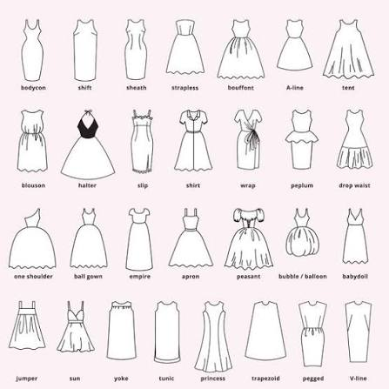

The Ultimate Guide to Every Type Of Neckline for Dresses
BY Lulus
Shop the Look: Molena Blush Pink Slip Midi Dress and Scarf Set, Gwyneth Beige Beaded Sequin Cowl Neck Mini Dress
Necklines do more work than you think. The shape framing your face and décolletage can completely transform a dress–making it feel office-ready, date-night perfect, formal, or effortlessly off-duty. And yet, most of us are still defaulting to the same two or three styles without realizing just how many options are out there. Whether you’re deep in a scroll session or standing in a fitting room, knowing your necklines is the kind of low-key style knowledge that pays off every single time. Ahead, all the different types of necklines you’ll encounter while shopping for women’s dresses—and exactly what to know about each one.

Dress Necklines:

Apron
Shop the Look: Mannon Slate Blue Floral and Bow Print Backless Maxi Dress
An apron neckline has a bib-like front that resembles an apron and often features straps that tie at the back of the neck.

Boat Neck
Shop the Look: Simply Beloved Light Pink Puff Sleeve Bodycon Midi Dress
A boat neckline extends from one shoulder to the other, creating a wide opening that looks like the curved profile of a boat.

Collared
Shop the Look: Willette Blue Collared Sleeveless Sweater Mini Dress
Collared necklines are defined by, naturally, their collar! The lapels fold down, creating a neckline that appears like the kind you see on men’s dress shirts.

Cowl
Shop the Look: Sidonia White and Gold Floral Cowl Sash Maxi Dress
A cowl neckline is a draped neckline that creates a soft, folded look around the neck

Halter
Shop the Look: Exceptional Status Rust Halter Backless Slip Midi Dress
A halter neckline is a style of neckline that features fabric that wraps around the back of the neck, leaving the shoulders and arms bare.

Mock
Shop the Look: Impressive Flirt Blue Floral Mesh Ruched Mock Neck Midi Dress
Mock necklines are similar to turtlenecks, but mock necks don’t fold over, and they aren’t as high, sitting snugly around the base of the neck.

Off-the-Shoulder
Shop the Look: Ainsley Cream Off-the-Shoulder Belted Mini Dress
An off-the-shoulder neckline is a style that sits below the shoulders, leaving them bare. It may have sleeves or straps that sit on the arms.

One-Shoulder
Shop the Look: Camellia Light Yellow One-Shoulder Bow Maxi Dress
A one-shoulder neckline is a style featuring one strap that goes over one shoulder and leaves the other shoulder bare.

Round-Neck
Shop the Look: Alexius Pink Floral Mesh Cutout Long Sleeve Maxi Dress
This is one of the most basic, typical shirt or dress neckline types that you’ll encounter in clothing. A round neckline is a simple, circular neckline that sits at the base of the neck.

Scoop
Shop the Look: Liliya Lavender Satin Jacquard Backless Maxi Dress
A scoop neckline is a U-shaped neckline that’s lower than a round neckline. Scoop dress necklines can resemble square necklines but are rounder, and usually have thinner straps.

Square-Neck
Shop the Look: Remarkable Arrival Plum Purple Floral Sleeveless Maxi Dress
A square neckline is a style that features a squared-off neck opening, often with wider straps that cover the tops of the shoulders.

Straight
Shop the Look: Laubrey White Floral Jacquard Mini Dress and Scarf Set
A straight neckline is a simple, straight line that sits across the chest, often at or just below the collarbone.

Strapless
Shop the Look: Kaletta Blue and Ivory Striped Eyelet Embroidered Midi Dress
A strapless neckline is a style that sits above the bust, leaving the shoulders and arms bare. It can come in lots of different shapes and often features hidden no-slip strips.

Surplice
Shop the Look: Still the One Emerald Green Floral Print Satin Maxi Dress
You’ve likely seen this word while shopping online and wondered “What is a surplice neckline?” Well, a surplice neckline is a style that features a draped or crossed front, creating a V-neckline. They may be a feature of convertible necklines as well.

Sweetheart
Shop the Look: Samai Red Cap Sleeve Bodycon Midi Dress
The sweetheart neckline is characterized by a curved, heart-shaped dip in the front. Sweetheart necklines are popular for their feminine and romantic appearance, and may or may not have straps.

Turtleneck
Shop the Look: Savanah Black Turtleneck Midi Sweater Dress
A turtleneck neckline is a style of neckline that covers the entire neck and extends upward to fold over. Turtleneck types of necklines are of course most popular on cold-weather clothes.

V-Neck
Shop the Look: Romy Cream Lace Tiered Shift Mini Dress
A V-neck is a style of dress neckline that forms a V-shape in the front, with the point of the V falling between the collarbones. V-necklines can vary in depth and width.

Prom Dress Necklines & Silhouettes: Your Ultimate Guide
Of the top 3 prom details—hair, makeup & outfit—choosing the best dress can be easier with our guide to Prom Dress Necklines & Silhouettes.
No way will you want to look “only average” on prom night. But what exactly do you want in a dress? Do you know what necklines appeal to you? Do you know what silhouettes are available?
We can help. Just study out little primer—and take it with you when you go shopping. It’ll get you started in your search and will help you navigate the scary waters of formalwear lingo.

Prom Dress Necklines & Silhouettes: Necklines
There so many different types of necklines to choose from—one flatters your shoulders, another elongates your neck, and others can even help define your shape. Here are some of the necklines you’ll find in the prom dress section:

· Bateau Neckline

· Halter Neckline
The halter is a classic that will never go out of style. It covers the torso—usually riding high—then goes around your neck to show off your shoulders and back.

· High Neck
This neckline can be very fitted while still being modest. It’s often used as the front of the bodice in a dress that has a particularly revealing back design.

· Scoop Neck
Scoop necklines vary so much, we simply can’t show them all. They can be cut higher or lower depending on the style of the dress, but the idea is that the neckline is rounded and not squared off or has any kind of definitive line—just a soft rounded look.

· Strapless
You can’t beat a strapless gown for showing off hair, makeup and accessories. If you love the style but want a little coverage, splurge on a pretty cover up like a shawl, pashmina, shrug or bolero.

· V-Neck
The V-neck is one of the sexiest necklines, but just like the scoop neck, it can be higher or lower, depending on the dress. If you need or want more support, stick with a structured fabric. If you’re comfortable rocking a Kate Hudson-type silhouette, then go for a V-neck as low as you dare!

· Illusion Neckline
If you want your look to be sexy but modest, then the illusion is the best neckline for you. You can wear a strapless dress but have your shoulders covered and still have the full support of a full opaque bodice. Illusion necklines are stunning either to show off the intricate beadwork or the dress itself or to frame a gorgeous statement necklace or earrings.

· Off the Shoulder
This is a stunning look if you want to be a little flirtatious but still have good support and possibly some coverage. Choose the sleeve of your off the shoulder dress to either complement or camouflage your arms.

Prom Dress Necklines & Silhouettes: Classic Silhouettes
The word “silhouette” refers to the overall cut of the dress. There are a million guidelines out there as to which silhouette looks best on which body type, but for now, we’re going to stick to a primer on the basic silhouette styles you’ll find in formalwear.

A-Line
This is a classic silhouette that elongates and can make the waist appear slimmer. As its name suggests, the basic outline creates a letter A. Choose any fabric and skirt type you like—structured, silky, flowing or fitted. There are plenty of A-lines to choose from!

Ball Gown
This is the definitive fairytale silhouette. Ball gowns can be made of unadorned fabrics like satin or velvet, but even if the fabric lines are “clean,” the silhouette itself will always be grand. If you choose a ball gown, stay a bit on the minimalist side when it comes to accessories.

Mermaid
This silhouette is perfect for taller girls, curvy girls, and even a shorter girl whose legs are longer than her torso. A mermaid dress will always fit closely, so make sure the style you choose lets you move, particularly in the knee area.

· Sheath
A sheath dress can come in many variations, but the basic idea is that the dress is a “vertical column” with no specific waistline detail and an overall straight skirt. Sheath dresses aren’t shapeless, though. They follow feminine curves but “skim” rather than cling.

· Trumpet
The trumpet silhouette is very much like the mermaid but is less restrictive in the thigh and hip. This style dress is also usually made of a stiffer fabric like satin or Mikado which holds the flared shape.

· Fit & Flare
Also similar to mermaid and trumpet, a fit and flare silhouette gently hugs the hips and then opens a bit below the knee. It’s not usually as full and gathered as a mermaid and is usually of softer fabric than trumpet styles.
The 25 common types of necklines include crew neck, V-neck, and scoop neck. These shapes frame the face and change the look of an outfit.

MasterClass +2
Basic and Classic Necklines
- Crew neck: A round, close-fitting collar that sits right at the base of the neck.
- V-neck: A cut that angles down into a sharp "V" shape at the chest.
- Scoop neck: A deep, wide, U-shaped opening that shows the collarbone.
- Jewel neck: A simple, round neckline that rests low on the throat.
- U-shape: A clean, rounded curve deeper than a standard crew neck.
- Square neck: Lines forming a geometric, sharp box frame over the chest.
- MasterClass +3

Open and Off-the-Body Necklines
- Boat neck: A wide, shallow line that runs horizontally across the shoulders.
- Off-the-shoulder: Sits entirely below the shoulders, exposing the collarbones.
- One-shoulder: An asymmetric cut with fabric over one shoulder and the other bare.
- Strapless: Features no straps or sleeves, resting flat across the chest.
- Spaghetti strap: Held up by very thin, delicate string-like shoulder straps.
- Halter neck: Secured by a band or strap that wraps around the back of the neck.
- MasterClass +2

Draped and High Necklines
- Cowl neck: Soft, draped folds of fabric hanging loosely around the throat.
- Turtleneck: A high, tight fabric tube that folds over the neck.
- Mock neck: A shorter version of a turtleneck that does not fold over.
- High neck: Rises up close to the jawline for full coverage.
- Illusion neckline: Sheer or mesh fabric covering the chest with a smaller inner shape.
- Queen Anne: A high back combined with a low, sculpted front neckline.
- MasterClass +2

Detailed and Shaped Necklines
- Sweetheart: Curved edges that mimic the top outline of a heart.
- Keyhole: Features a small cutout opening or hole right below the throat.
- Surplice: Fabric wraps diagonally across the front to form a V-shape.
- Asymmetrical: Lacks symmetry, featuring uneven or slanted cuts.
- Collared: Includes an attached tailored collar like a button-down shirt.
- Scalloped: Decorated with small, repeated semi-circle fabric curves along the edge.
- Ruffle: Trimmed with gathered, ruffled fabric along the collar edge

The Ultimate Guide to the 27 Types of Necklines

Share
Find the perfect shirt or dress neckline to flatter your body type
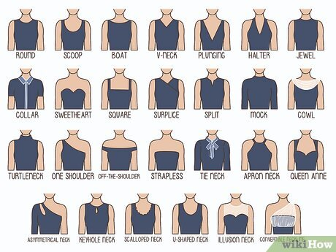
The right neckline can enhance your whole outfit, whether it’s on a shirt, a nice blouse, or a wedding or prom dress. But with so many necklines out there—including ones you didn’t realize there was a name for—you might not know which one is best for your body type. That's why we’ve compiled a complete guide to 27 neckline types. Keep reading for the comprehensive breakdown, featuring expert styling tips from image consultant Kalee Hewlett and wardrobe stylist Paul Julch, MA.
Most Flattering Necklines for Every Body Type
- Cowl, scoop, and V-neck necklines flatter almost all body types.
- Sweetheart, illusion, and square necklines elongate the upper body, making them ideal for pear and petite shapes.
- Halter, boat, and off-the-shoulder necklines accentuate the shoulders, flattering those with straight or hourglass shapes.
1

Crew neck
A crew neck, or round neck, sits below the bottom of the neck. The simple shape is a staple of casual tops like T-shirts and tanks.^{[1]} A crew neck draws the eyes to your face and shoulders, making it ideal for those with slender shoulders, a long neck, or a large bust.^{[2]}
  - Who is it best for? If you have a pear body shape, wear a top with a crew neck to add width to the upper half of your torso.
  - A classic crew neck shirt with long sleeves is perfect for layering under overalls, says Hewlett.^{[3]}

Scoop neck
A scoop neck is rounded like a crew, but sits lower. Its deep ‘scoop’ shape lengthens the neck, while accentuating the collarbone and décolletage (the area just above the bust).^{[4]} A scoop neckline frequently appears on semi-formal dresses. The best part? It’s universally flattering.^{[5]}
  - Who is it best for? Scoop neck tops or dresses are especially flattering for those with small busts, shorter necks, or angular face shapes.^{[6]}
  - If you have a box body shape, a scoop neck can help to add a sense of curves to your silhouette while lengthening your neck. Look for cinched or belted tops or dresses to help define your waist.
3

Boat neck
Download Article
- 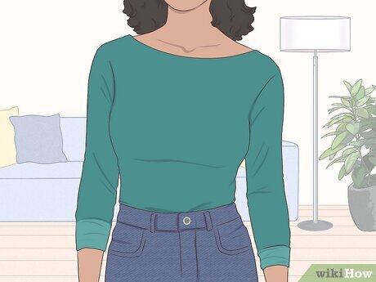
The boat neckline is a wide oval that sits below the collarbone. It’s also known as the bateau neckline, but its boat moniker comes from its history as sailors’ go-to style in the early and mid-20th century.^{[7]} A classic silhouette, the boat neck accentuates the shoulders and neck, creating balance for those with narrow shoulders or wider hips.^{[8]}
  - Who is it best for? Boat neck tops and dresses are ideal for those with narrow shoulders, long necks, and oval or round faces.^{[9]} If you have a pear body shape, a boat neck can add the illusion of width to your upper body.
  - High versions of the boat neck are also known as the Sabrina neckline, because Audrey Hepburn popularized the silhouette in the 1954 film of that name. In wedding gowns, they’re similar to a portrait neckline.
4

V-neck
Download Article
- 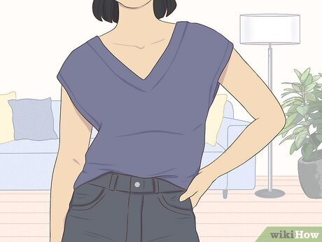
A V-neck has two lines that drop down into a V-shape. The depth of the V depends on the garment—shirts typically have high V-necks, while a dress might have a deeper V.^{[10]} The classic V-neck is another neckline that flatters every body type, though it’s especially well-suited for those with heart and petite body shapes.^{[11]}
  - Who is it best for? Anyone! If you have a smaller bust, a modest V-neck is fine. Go for a deep V if you have a larger bust—it will help balance out your upper and lower torso.
  - Because V-necks lengthen the neck, if you have a longer neck, layer a tank or camisole underneath to offset the effect.
  - “A white V-neck t-shirt with a cute blazer and jeans can look like a very intentional outfit,” says Julch^{[12]} Pair these pieces for an easy polished look.
5

Plunging neckline
Download Article
- 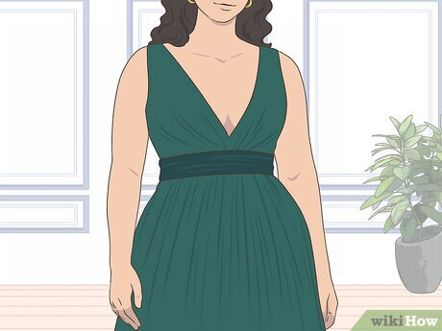
A plunging neckline is a very deep V-neck. The dramatic neckline is a common choice for wedding dresses, but it’s also featured in evening wear and dressy blouses. It offers a sexy silhouette that exposes more of the décolletage and bust. A plunging neckline is ideal for those with larger busts or shorter torsos, as it frames the chest while elongating the body.^{[13]}
  - Who is it best for? Those who want to elongate their upper body and show off their bust. Regardless of your bust size, you’ll likely need fashion tape to help keep a plunging neckline in place.^{[14]}
  - Plunging necklines can dip from below the bust to as low as the belly button.
  - For wedding dresses, look for a plunging neckline with a sheer or nude mesh insert to offer extra support, if desired.
6

Halter neck
Download Article
- 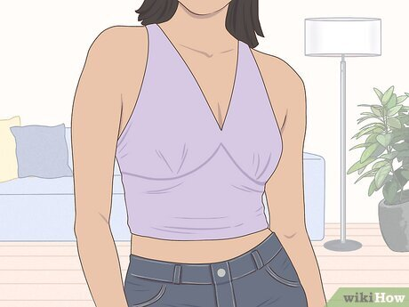
Halter necklines wrap around the back of the neck, forming a narrow V-shape. They come in many varieties, from summery Y2K tops with thin straps that tie behind the neck to thick straps that twist in front of the neck. This neckline accentuates the shoulders while drawing the eye upward—perfect for those with medium to full busts and wide shoulders.^{[15]}
  - Who is it best for? If you have an hourglass body shape, a halter neckline is especially flattering as it highlights your shoulders without throwing your overall silhouette off balance. It also suits rectangular body types.^{[16]}
  - Halter necklines are a great way to show skin without revealing more of your bust and décolletage than you’re comfortable with.
7

Jewel neck
Download Article
- 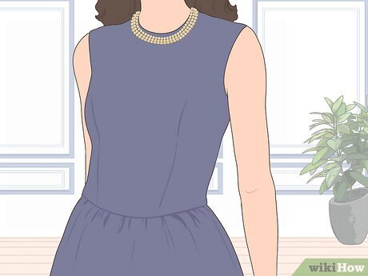
A jewel neck is a high, rounded neckline. It typically lands at the base of the throat, making it ideal for modestly showing off necklaces (hence the name). First ladies from Jacqueline Kennedy to Michelle Obama have worn dresses with jewel necklines. Go for this style if you’d like a classy, elegant look.^{[17]}
  - Who is it best for? A jewel neck’s high placement draws attention to the face and gives the illusion of width to the shoulders. If you have a pear body shape, opt for this neckline to help balance out your upper body.
8

Collar neck
Download Article
- 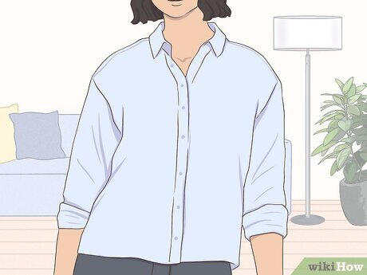
A collar neck features a rounded collar detail. Featured in many blouses and jackets, this neckline makes you look more put-together and polished. Plus, if your collar has buttons, you can control how much skin you want to show. Leave more buttons undone for a sexier casual look—or close it completely for a more formal presentation.^{[18]}
  - Who is it best for? If you have a heart body shape or a pear body shape, collars can even out your silhouette by widening or lengthening your torso’s upper half.
  - Those with small busts and rectangle body shapes look great in statement collars—such as the Peter Pan collar.^{[19]}
9

Sweetheart neck
Download Article
- 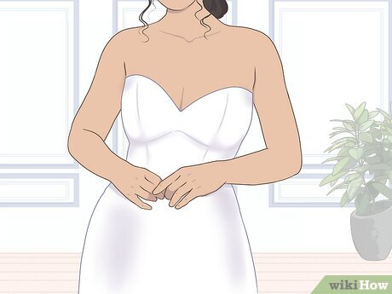
A sweetheart neckline is heart-shaped and strapless. Specifically, it resembles the top half of a heart for a romantic, feminine look. On wedding dresses, it’s also known as the princess neckline. Because it’s strapless, a sweetheart neckline tends to sit low on the bust, though more modest options are available.^{[20]}
  - Who is it best for? If you have a shorter neck, a sweetheart neckline will help elongate your upper body because of its low placement.^{[21]}
  - The sweetheart neck isn’t just for dresses. Look for bustier and princess-style tops to help you rock the look in daily life.
- EXPERT TIP
- 
- Kalee Hewlett
- Image Consultant
For rectangle body shapes, use your neckline to create curves. Opt for scoop, V and sweetheart necklines to add more shape to your silhouette. Puff sleeves and shoulder pads are great for adding volume to the shoulders, while peplum details are great for adding more width to the hips.
10

Square neck
Download Article
- 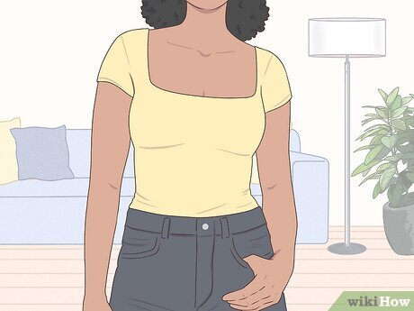
A square neck drops into a square above the bust. This is a classic, romantic silhouette featuring a straight horizontal line over the bust and two straight straps or sleeves perpendicular to it. If you’d like to highlight your bust (and a necklace), choose a square neckline bodysuit or dress.^{[22]}
  - Who is it best for? This neckline fuses modesty and sensuality by covering your shoulders while drawing attention to your collarbones. It’s especially flattering on an hourglass figure.^{[23]}
11

Surplice neck
Download Article
- 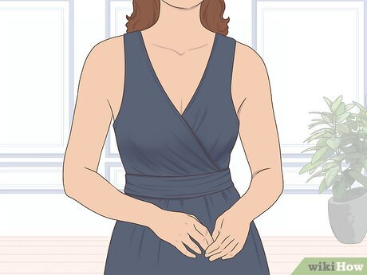
In a surplice neck, fabric crosses over itself to form a V-shape. It’s a common silhouette on wrap dresses. However, a traditional surplice neckline is sewn in at the waistline and not adjustable as it is in a wrap dress or top. While it resembles a V-neck, this neckline is unique in the way it features two overlaid pieces of fabric.^{[24]}
  - Who is it best for? Wrap tops are especially flattering on apple body types, helping to define the waist and create the illusion of wider hips.^{[25]}
  - Looking to define your waistline? Choose a surplice dress with a cinched waist.
12

Split neck
Download Article
- 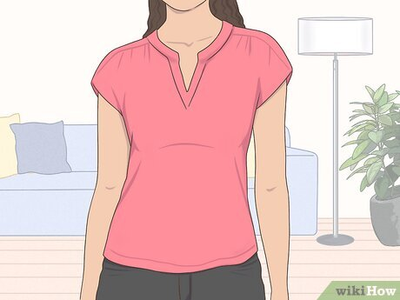
A split neck features a small gap in its center. It’s typically a split crew neck, though splits can appear in boat or scoop necklines as well. Unlike a V-neck, a split neck leaves only a small, narrow divot in the neckline to help open it up and show more of the neck. Some split necks have button closures to fasten or turn them into a keyhole.^{[26]}
  - Who is it best for? Like a crew neck, a split neck silhouette will flatter you most if you have a small to medium bust and a long neck.
13

Mock neck
Download Article
- 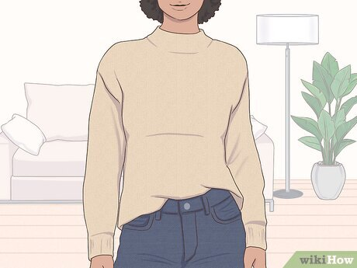
A mock neck is a short collar at the base of the neck. Unlike a turtleneck, it doesn’t cover the whole neck—nor is it folded over. The casual mock neck is most often found on cold-weather clothing like sweaters and long-sleeved shirts. This neckline was especially trendy in the 1960s.^{[27]}
  - Who is it best for? If you have a shorter neck, opt for a mock neck over a turtleneck for the same illusion without the severe height.^{[28]}
  - If you have a smaller bust, a high neckline is a particularly flattering option.^{[29]}
14

Cowl neck
Download Article
- 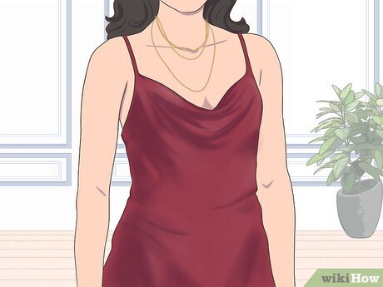
A cowl neckline is loose and draped to create round, U-shaped folds. Lower cowl necks on dresses, jumpsuits, or camisoles offer a chance to show off your décolletage. The look is typically draped above the bustline to draw attention to your face.^{[30]} If you have a short or sturdy torso, opt for an open neckline like the cowl neck to draw the eyes upward.
  - Who is it best for? Those with triangle shapes and a narrow upper body. In the wintertime, look for sweaters with high cowl necks to create the illusion of a scarf. The classic look adds dimension and volume to the upper half of your body—without shortening your neck like a bulky turtleneck would.
15

Turtleneck
Download Article
- 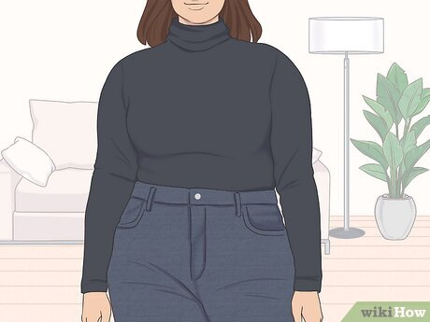
A turtleneck is a high, straight collar that hits below the chin. It’s typically worn folded down around the neck. Like a jewel neck, it offers a modest backdrop for showcasing your favorite neck candy. It’s also a popular choice in the winter because it lends itself to layering when the temperatures drop.^{[31]}
  - Who is it best for? Turtlenecks are especially flattering if you have a long face shape or neck, helping to balance the top of your silhouette.^{[32]}
16

One Shoulder
Download Article
- 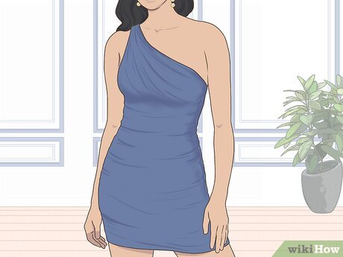
A one-shoulder neckline has a diagonal shape for an asymmetrical silhouette. As the name suggests, this look only covers one shoulder, either with a single sleeve or strap. The dramatic silhouette can elevate simple looks, whether you pair a one-shoulder blouse with your favorite miniskirt or rock a one-shoulder dress to a party. It evokes the togas and robes worn by ancient goddesses.^{[33]}
  - Who is it best for? A one-shoulder garment draws the eye upward to your face while showing slightly more skin than a typical neckline. If you have wide shoulders, consider rocking a flattering one-shoulder look that will emphasize your upper body.
17

Off-the-shoulder
Download Article
- 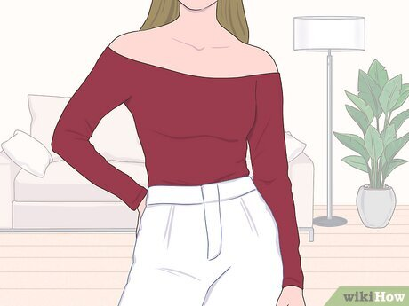
An off-the-shoulder neckline hangs straight below the shoulders. It’s also known as the Bardot neckline because it was popularized by actress and model Brigitte Bardot in the 20th century. By exposing the shoulders, you create the illusion of a narrower waist, making it ideal for pear and box body types.^{[34]}
  - Who is it best for? The flirty look is extra flattering if you have narrow shoulders or a fuller midsection, as it lengthens and draws attention to your shoulders.^{[35]}
  - If you’re worried about your top rising up, Hewlett has a hack. First, attach two safety pins to each end of a hair elastic. Pin them on the top’s inside seams underneath the armpit. Repeat on the other side.^{[36]}
    - Your armpits will be above the hair ties, keeping the top from rising when you move your arms.
18

Strapless
Download Article
- 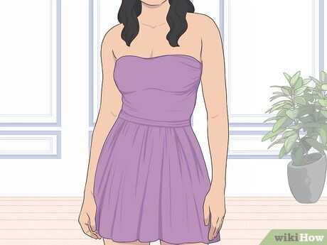
A strapless neckline cuts across the top of the bust, either straight or curved. Because it has a low cut, it highlights your upper body, especially the collarbone and neck. On wedding or formal dresses, it might be curved into a sweetheart neckline or left straight for a classic look. If you have a long neck, a strapless neckline can accentuate your figure.^{[37]}
  - Who is it best for? Strapless necklines can flatter many body types—just make sure you have the right strapless bra, fashion tape, or fit to support your bust.^{[38]}
19

Tie neck
Download Article
- 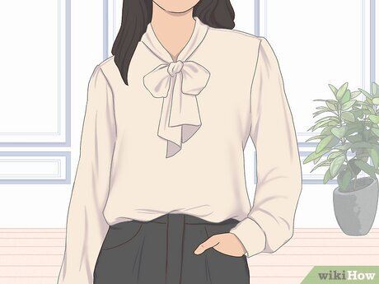
Tie necks are usually high and rounded, with a chic bow detail. Also known as bow tie necks or pussycat bow necklines, these silhouettes add dimension and volume to a regular high collar. Choose to tie a bow at the base or side of your neck.^{[39]}
  - Who is it best for? Tie-neck tops are especially flattering for rectangle body shapes when the top or dress is sleeveless, as the bow draws the eye to the neck and face.
  - Some tie-neck tops combine the tie element with a V-neck for a more revealing take on this sophisticated silhouette—opt for these if you want a dressy look that doesn’t feel too formal.^{[40]}
20

Apron neck
Download Article
- 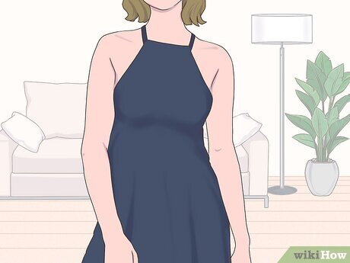
An apron neckline narrows inward to the neck like a triangle. Inspired by the old-fashioned aprons of 20th-century housewives, the neckline is similar to a halter. However, it’s unique because the neckline itself only extends the width of the neck before sloping down to the sides of the bust. Thin straps come up from each side of the neckline, circling around the back of the neck.^{[41]}
  - Who is it best for? An apron neckline flatters every body type. Go for a dress or top with this design if you want to show off your collarbone and shoulders.
21

Queen Anne
Download Article
- 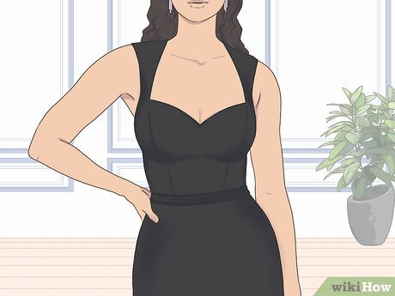
A Queen Anne neckline features a high back and low front like a trapezoid. The back has a high collar that loops around to the front with narrowing straps, resembling the cut of a bolero top.^{[42]}
  - Who is it best for? If you have broad shoulders, this regal neckline can help to slim them while accentuating your bust.
  - If you’re a bride having a vintage-themed wedding, consider a Queen Anne neckline for your gown to create a classic look—like the one Kate Middleton wore on her big day.^{[43]}
22

Asymmetrical neck
Download Article
- 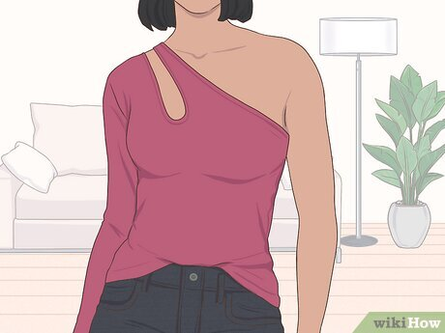
An asymmetrical neckline features two different sides for an irregular shape. While it could simply be a one-shoulder neckline, this style encompasses any silhouette that doesn’t parallel itself. For example, some tops have an off-the-shoulder sleeve on one side and a cap sleeve on the other. Other tops create asymmetry with cut-out details that add interesting geometric lines—these tend to be higher, so the peekaboo can land over the collarbone or bust.^{[44]}
  - Who is it best for? Because asymmetrical necklines come in different varieties, this cut flatters every body type. One-shoulder varieties are perfect for showing off your shoulders and collarbone.
23

Keyhole neck
Download Article
- 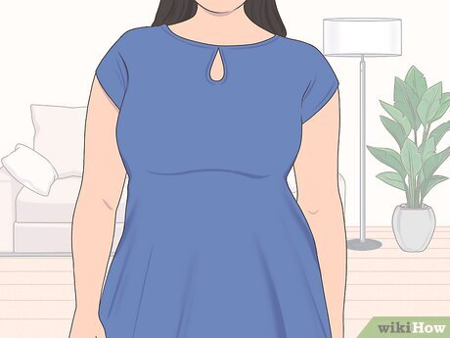
A keyhole neckline is rounded with a cutout below the collarbone. The cutout is buttoned or sewn at the top, creating a shape that resembles a keyhole. This neckline lets you show skin in a sophisticated manner. Paired with a high neckline, it exudes elegance. Plus, it can help to balance out the lines of your favorite dangly statement earrings!^{[45]}
  - Who is it best for? Any body type. Keyhole necklines come in different sizes for different levels of modesty.^{[46]} A small keyhole might be too tight on a larger bust, while a large keyhole may hang too loosely if you have a smaller bust. Balance is key.
24

Scalloped neck
Download Article
- 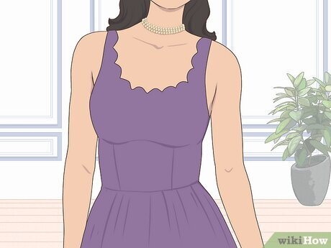
Scalloped necklines have a repeating, curved pattern. They’re so named for their resemblance to a row of scallop shells. More a design than a specific neckline, the scalloped look most often appears on scoop neck and V-neck tops or dresses.^{[47]}
  - Who is it best for? If you have a box body shape, choose this neckline to disrupt the lines of your silhouette and appealingly frame your bust.

U-Shaped neck
- A U-shaped neckline dips above the bust like a U. Narrower and often higher than a scoop neck, this cut is a popular choice for tank tops and t-shirts. While it can reveal cleavage, it doesn’t have to—many U-shaped tops simply lengthen the neck without fully displaying your bust. They’re also a great choice when you want to show off a mid-length necklace.^{[48]}
  - Who is it best for? Treat the U-shaped neckline like you would a scoop neck. If you have a shorter neck, wear a tank top with a U-shaped neckline to draw the eye downward and balance your torso. It can also create the illusion of a fuller chest.

Illusion neck
- A high, sheer illusion neckline creates the appearance of a strapless look. However, it features a transparent or nude-colored mesh fabric that typically extends over the neck (rounded at the collar) for extra support and coverage. This neckline isn’t found in tops, but is popular in wedding dresses and other formal gowns. Some illusion necklines have beading or other detailing on the mesh section.^{[49]}
  - Who is it best for? Like a sweetheart neckline, an illusion neck elongates your upper body. If you have a shorter neck, consider a dress with an illusion neckline—especially if you’re worried about your medium to large bust supporting a strapless neckline.

Convertible neckline
- A convertible neckline features rearrangeable straps to create different shapes. Rather than being one consistent shape, it’s adjustable to two or more neckline types. For example, a dress may have a ruffled, off-the-shoulder neckline that can also be pushed over the shoulders to wear as a boat neck.
  - Who is it best for? Anyone, as you can modify it to flatter your body type! These necklines are popular on bridesmaid dresses, allowing members of the wedding party to customize the neckline to suit their shape.
Choose a Wedding Dress

Everything About Heels: Heights, Shapes, and Styles
Published on 20/04/2026
Heels come in an array of heights and shapes, and can be found across a diverse range of shoe styles. With so many options, finding the perfect pair can be a challenge. To guide your search, we have categorized heels by height and shape, detailed the key characteristics of each, and provided recommendations on how to style them. We hope that by understanding how these heels influence you

Heel Types At A Glance
Heel Type | Key Characteristics & Feel | Comfort Level | Best For
Kitten Heels | Low, slender heels that distribute weight more evenly to reduce foot strain. | ★★★★☆ | Beginners, office wear, all-day comfort.
Stiletto Heels | Ultra-thin heels that concentrate pressure on the forefoot with minimal stability. | ★☆☆☆☆ | Formal events, evening wear.
Slingback Heels | Heels featuring back straps for support, though they offer less security than closed styles. | ★★★☆☆ | Office to evening wear, versatile day-to-night styling.
Platform Heels | High heels with raised front soles that decrease heel incline and reduce arch pressure. | ★★★★☆ | Parties, glamorous looks, statement outfits.
Wedge Heels | Full-length heels that distribute weight evenly across the foot for added stability. | ★★★★☆ | Casual wear, festivals, summer outfits.
Block Heels | Heels with a wide base that improve balance and reduce pressure points. | ★★★★☆ | Long hours, work, smart-casual looks.
Heeled Mary Janes | Heels with instep straps that enhance the fit and keep the foot secure. | ★★★★☆ | Casual, feminine, academia-inspired outfits.
Heeled Boots | Enclosed design providing structure and ankle support. | ★★★★☆ | Fall/winter, wet weather, everyday wear.
Heeled Sandals | Open design with minimal coverage that can create pressure points even at moderate heights. | ★★★☆☆ | Warm weather, vacations, casual outings.
Heeled Mules | Backless design that reduces stability, especially as heel height increases. | ★★☆☆☆ | Casual wear, effortless styling.
Pumps | Closed-toe heels that stabilize the foot through structured coverage. | ★★★★☆ | Office, formal, and business settings.
In the sections below, we will discuss heeled shoes of various heights, shapes, and styles in detail.

Types of Heel Height
Heels come in a wide spectrum of heights. In this section, we will delve into the specifics of four types of heel heights—kitten heels, mid-height heels, high heels, and platform heels.

Kitten Heels
Short and slender, kitten heels are typically 1 to 2 inches tall and often feature a curved silhouette set slightly inward from the back of the shoe. They are a favorite for those who want a flattering lift without the physical strain associated with higher heels. Often called "training heels," these low and dainty designs are popular among beginners because they are easy to walk in while remaining polished and elegant. With a distinct '90s aesthetic, kitten heels offer a perfect balance of femininity and practicality—making them a versatile choice for almost any occasion.
Discover more in our in-depth guide to kitten heel styles, types, and outfit styling tips.

Mid-Height Heels
Usually standing at 2 to 3 inches, mid-height heels are considered the gold standard for office and formal wear. Known as the "classic pump" height, they are favored for everyday use as they create a noticeable but moderate arch, elongating the leg without sacrificing balance or comfort. Occupying the sweet spot of the heel spectrum, they are high enough to elevate your look but low enough to maintain a natural gait. These sensible heels are excellent all-day shoes, providing comfort for hours while transitioning seamlessly from business meetings to dinner dates.

High Heels
Heels exceeding 3 inches are generally classified as high heels, with some towering designs reaching 4 inches or more. This elevation puts the foot on a steeper incline, shifting the wearer's center of gravity. This shift emphasizes calf muscles and leg lines while naturally drawing the shoulders back, resulting in a more poised and confident posture. These benefits make high heels a popular choice for formal events and special occasions. A symbol of power and glamour, high heels are the go-to when you want to stand out and make an impact.

Platform Heels
A platform heel typically exceeds 6 inches in height and features a thick sole under the front of the foot. The heel itself must be higher than the platform to maintain the downward incline. This front sole effectively reduces the slant, making the shoe significantly more comfortable for extended wear—a 12 inches heel with a 2 inches platform feels more like a 6 inches elevation. The combination of extreme height, stability, and comfort makes platform heels a popular choice for high-fashion moments and nights out. Their bold, architectural aesthetic makes them the perfect statement piece to anchor any outfit.

Types of Heel Shape
The shape of a heel can dramatically change the aesthetic of a shoe. In this section, we discuss the characteristics of various heel shapes and identify the best occasions for each.

Stiletto Heel
The term "stiletto" refers to a knife or dagger with a slender, pointed blade. Fittingly, stiletto heels are thin, tapered, and come to a sharp point at the base. They are typically very high, usually standing 3 inches or taller. While widely considered a fashionable, glamorous choice, they can be more challenging to walk in than wider-based heels. Stiletto heels offer a leg-lengthening effect and add a bold, sharp edge to any ensemble. These traits make them the perfect choice for occasions where you want to project power and confidence, such as black-tie galas, red-carpet events, or high-stakes business meetings.

Block Heel
Block heels feature a wide, substantial base. They come in various shapes—rectangular, cylindrical, and trapezoidal are the most common. Found on everything from sandals to pumps and boots, they are practical for daily wear because their chunky construction ensures even weight distribution and enhanced balance. The clean-lined design gives them a modern, effortless vibe, serving as the "cool girl" alternative to stilettos. Comfortable enough for busy days on your feet, they are ideal for commuting, long office hours, or outdoor events where walking on uneven surfaces like grass is required.

Cylindrical Heel
As the name suggests, the cylindrical heel is a perfectly rounded column, resembling a pillar. It offers unique 360-degree symmetry and a curved silhouette that lends an air of fluid, polished sophistication. With a minimalist and contemporary aesthetic, these heels appeal to those who appreciate striking, architectural construction. They are ideal for art gallery openings, creative office environments, or dressy date nights.

Cone Heel
A cone heel features a wide circular top that tapers to a narrower point—visualize an ice cream cone. This triangular silhouette creates a sturdy connection to the body of the shoe. Cone heels have a playful, feminine vibe with a touch of bohemian flair. Offering good stability and comfort, they are a great option for off-duty looks or relaxed workwear, and can be used to add a soft touch to edgy denim styles.

Flare Heel
Emerging in the 1970s, the flare heel remains a popular choice today. Characterized by a slim top that flares out into a wider base, it combines the elegance of a thin heel with the stability of a block heel. While eye-catching at any height, high flare heels (3 inches and above) are particularly striking, adding a dramatic flair that elevates any look. These heels feel more fashion-forward than a standard block heel, making them perfect for trend-driven or editorial ensembles. However, they can also be dressed down for everyday wear—pair them with wide-leg trousers for a sharp, professional look.

Sculptural Heel
Sculptural heels are where creativity thrives. These are heels designed with non-traditional, decorative, or geometric forms—such as spheres, stacked cylinders, or abstract hardware—that deviate from standard silhouettes. Often resembling pieces of art, these heels are typically the focal point of the shoe. Whether made of wood, metal, or other materials, they add an avant-garde touch to any outfit. While not always the most comfortable choice, they are the go-to for serious trendsetters looking to make a statement. Perfect for fashion parties or photoshoots, they can also transform simple everyday attire into a conversation starter.

Wedge Heel
The beauty of wedges lies in their seamless design, where the heel is not separated from the sole but runs from the back to the front, filling the entire space under the arch. This provides exceptional comfort and stability, as weight is distributed evenly across the foot. With a relaxed, summer-friendly aesthetic, wedges are popular in warmer months, especially when crafted with espadrille, cork, or jute soles. They are the ultimate vacation shoe and work beautifully for summer weddings or casual brunches.

Types of Heeled Shoes
Classifying heeled shoes by the design of their uppers is helpful, as these elements dictate both the look and the fit of the shoe. In this section, we define common shoe styles, discuss their versatility for various occasions, and address their comfort.

Pumps
Pumps are covered, slip-on shoes with low-cut vamps and no fastenings or straps. These classic, versatile shoes come in various toe shapes—pointed pumps are the most common, while round and square versions offer a charming retro aesthetic.
Known as the "power shoe" due to their timeless design, pumps are a staple in professional settings. They are a fail-safe choice for the boardroom, formal ceremonies, and business events. Because they lack straps, pumps can sometimes slip, and the low-cut vamp may pinch the toe box—the widest part of the foot—meaning their comfort level can vary.

Slingback Heels
Slingback heels feature a closed toe and an open back secured by a strap that "slings" around the heel, typically elasticized or buckled for a snug fit. They are often paired with kitten, cylindrical, or block heels. While typically pointed or almond-toed, square-toed versions offer a modern finish.
While generally considered more relaxed than pumps, slingbacks retain an understated, luxurious quality suitable for business-casual offices, non-formal weddings, and date nights. They often fit better than open-heel or closed-heel shoes because the straps secure the foot while allowing for natural movement. For maximum comfort, avoid overly tight straps or rough materials. They also provide better ventilation than fully covered shoes. Browse our comprehensive guide to choosing and styling slingback heels.

D'Orsay Heels
D'Orsay heels are defined by cut-out sides that expose the arch of the foot. This elegant style carries a glamorous, old-world vibe, pairing beautifully with stiletto or sleek blade heels. Frequently featuring pointed toes, they create a continuous, leg-lengthening line from the arch to the toe.
Exuding classic charm and elevated femininity, these are perfect for date nights, cocktail parties, and creative offices. Their comfort level is low to moderate, as the missing sides provide less lateral support, requiring the foot to exert more effort to stay in place. Proper fit is crucial to mitigate this.

Heeled Sandals
Heeled sandals are open-construction shoes secured by straps (e.g., ankle, toe, or T-bar). Popular styles include strappy sandals, crossover-strap designs, and thong sandals. They always feature an open toe for maximum breathability.
Their vibe depends on strap design and thickness, but they are generally seen as casual, warm-weather footwear. However, elaborate designs with towering heels can easily complete formal evening ensembles. Comfort varies: pairs with thicker straps and block heels are generally more pleasant to wear than those with thin straps and slim heels.

Heeled Mules
Heeled mules are slip-on, backless shoes with no securing straps. Versatile and minimalist, they are often paired with kitten or block heels, as the low, sturdy heel makes them easier to walk in. They come with open, closed, or peep toes.
Effortless and modern, mules offer an instant sense of cool-girl ease. Best for dinner dates or casual outings, they are ideal for activities that don't involve much walking. Because the backless design means less contact with the foot, they are less prone to friction-related discomfort. However, you do need to "grip" the shoe with your toes to keep it in place, which can cause fatigue over time.

Heeled Mary Janes
Heeled Mary Janes are defined by their closed toes and one or more instep straps. Traditionally, they feature round or square toes that provide a youthful, vintage charm. They often come with chunkier heels like block, flare, or sculptural heels.
Drawing on the iconic schoolgirl aesthetic, they offer a preppy-chic vibe perfect for academic settings or the office. The instep straps act as a safety belt for the foot, keeping it secure and reducing toe strain, which leads many to consider these the most comfortable heeled shoes.

Heeled Boots

Heeled boots are closed shoes with shafts extending up the leg, from the ankle to the thigh. While they can feature any heel, they are commonly paired with block, flare, or blade heels. Stiletto-heel boots, especially in pointed-toe versions, offer a high-fashion, leg-lengthening effect.
Boots add weight to an outfit and make any look feel more intentional. While inherently autumn-winter footwear, heeled versions aren't suitable for wet or slippery conditions and are best for dry days. They provide excellent stability by encasing the foot and ankle, making higher heels feel more manageable.
In this comprehensive guide, we have surveyed the diverse world of heels by height, shape, and style. By detailing the characteristics, pros, and cons of each, we hope to help you make more informed footwear choices. Find your next favorite pair by browsing our extensive collection!

28 Types of Heels: Different Styles That You’ll Love
With so many different types of heels to choose from, how do you find the perfect fit? Heels can be a woman’s best friend and, sometimes, her worst enemy. A heel is a shoe style designed with an elevated rear part, lifting the heel higher than the toes.
Whether you want to make a fashion statement or add a few inches to your height, the right pair of heels can make all the difference. From the comfortable block heel to the daring stiletto, we’re diving into each style’s unique characteristics, advantages, and best uses.

Types of Heels

Block Heels
Block heels are a thick, square-shaped heel that provides stability and support. Designed for comfort and versatility, they are a practical choice for extended periods of wear. They can be styled effortlessly with both formal and casual outfits.

Kitten Heels
Kitten heels are low, narrow heels, typically no higher than 2 inches. They offer a slight lift for those seeking a comfortable yet polished look.
These kinds of heels work well for occasions like garden parties or office settings. They are the perfect pair for different outfits, from trousers to simple dresses.

Stiletto Heels
Stiletto heels are tall, narrow heels, often over 4 inches, designed to create a dramatic look. Their slim base requires balance, making them better suited for occasions with minimal standing or walking.
From red carpet events to intimate dinners, these quintessential high heels, add a striking appeal to any outfit.

Cone Heels
Cone heels have a distinct silhouette, narrowing at the top and widening toward the base, similar to an ice cream cone. With more stability than stilettos, they are a stylish option for semi-formal to formal events like weddings.

Wedge Heels
Wedge heels are shoes with a continuous, wedge-shaped sole that extends from the heel to the middle or front of the shoe. The wedge style is the most comfortable heel to wear.
Their solid base offers stability, making them suitable to wear for long periods. Commonly associated with spring and summer, they often feature materials like cork or straw and pair well with seasonal dresses and skirts.

Pumps
Pumps are heels with a low-cut front, closed toe, and heel height that varies depending on the style. Available in range of styles like stiletto, block, or kitten heels, pumps are known for their classic and adaptable look.
Perfect for transitioning from office wear to evening outings, they are a versatile design made from materials such as leather, suede, or synthetics.

Platform Heels
Platform heels feature a thick sole under the front of the foot paired with a heel that can vary in style, such as stiletto or block. The raised sole reduces the steep incline, making the height more manageable and comfortable.
Ideal for adding extra height and making a bold statement, platform heels work well for special occasions like nights out or formal events.

Spool Heels
Spool heels have a distinctive hourglass shape, wider at the top and bottom and narrower in the middle. This design resembles a spool of thread.
Spool heels offer a vintage vibe, harking back to European courts and 18th-century fashion, yet they have a timeless quality that allows them to pair well with modern outfits.

Chunky Heels
Chunky heels, as the name implies, feature a thick, rectangular base that offers both height and ease of walking. They’re the middle ground between stilettos and block heels.
These heels can easily transition from day to night. Whether pairing them with a business suit or a mini dress, chunky heels offer a stylish yet practical choice.

French Heels
Also known as Louis or pompadour heels, French heels have a curve at the back, lending a feminine and antique aesthetic. These heels are historically associated with 18th-century French courts. Sometimes confused for spool heels, pompadour heels are more dramatic and ornate.
They’re often reserved for more ceremonial or formal occasions and make for a striking addition to period-inspired costumes. Just as French heels carry the elegance of 18th-century French courts, Mondly lets you pick up the French language to match.

Ankle Strap Heels
Ankle strap heels feature a strap that wraps around the ankle. This offers an aesthetic appeal and additional support.
These heels work well for events where you might need extra security in your step, such as weddings or dance parties.

Peep-Toe Heels
Peep-toe heels offer a small opening at the front, allowing the tips of the toes to show. This style is a playful contrast to traditional closed-toe heels.
Whether you’re attending a summer wedding or going out for a night on the town, peep-toe heels offer a hint of flirtiness.

Slingback Heels
Slingback heels come with a strap that crosses around the back of the heel or ankle, eliminating the need for a complete enclosure around the heel. This gives your feet a bit more freedom.
They’re an elegant choice for a wide range of activities, from office settings to formal events. The back strap offers enough support to keep you confident in your stride.

Mule Heels
Mule heels are backless and often closed-toe, making them easy to slip on and off. Their open-back style gives them a casual, laid-back vibe for everyday wear. But they can also step up to sophistication depending on the material and design.

Heeled Sandals
Heeled sandals are open-toe shoes that combine the breezy design of sandals with the height of a heel. They come in a variety of designs, from minimalist ankle straps to intricate lace-up styles, and can feature different heel types like stiletto, block, or wedge.

d’Orsay Heels
D’Orsay heels offer a cutaway design at the sides, exposing the arch of the foot. This creates a more revealing look, making these heels particularly suited for formal events or romantic dinners.
If you aim to make a fashion-forward statement while still keeping it classy, D’Orsay heels might be your go-to.

Flared Heels
Flared heels have a base that spreads out at the bottom, resembling a bell. This gives them an extra bit of stability. Often seen as a fashion-forward choice, these heels add a dash of drama to your step, making them perfect for events where you want to stand out.

Pin Heels
Pin heels, or needle heels, are extremely thin and delicate, similar to stilettos but even finer. They’re all about elevating the drama of an outfit but are not built for comfort or long periods of wear. These types of high heel shoes need skilled walking.

Cuban Heels
Cuban heels are stacked, medium-height heels with a straight-cut back and a slightly tapered front. They’re often found on both men’s and women’s shoes, including boots.
Cuban heels offer a robust and masculine vibe, making them suitable for outfits that call for a bit of edge. They’re versatile enough to pair with anything from skinny jeans to dresses.

Square Heels
Square heels are known for their square-shaped base, offering a stable and comfortable option for longer wear. Their geometric design adds a modern edge to footwear, making them a stylish choice for both professional attire and casual outfits like summer dresses.

Espadrille Heels
Espadrille heels are summer-ready shoes with a fabric upper, typically canvas or cotton, and a woven jute sole. Their relaxed, beachy style makes them ideal for warm-weather events. Perfect for adding a breezy, bohemian flair, they are a staple for casual yet chic outfits.

Lace-up Heels
Lace-up heels feature laces that can wrap around the foot, ankle, or even higher up the leg. Depending on the design and how they are laced, they offer a personalized fit and lend an edgy accent to your outfit.

Cork Heels
Cork heels feature a base made of cork material, providing a lightweight and more comfortable experience. The cork material adds an earthy, natural element to the shoe, making it a favorite for outdoor gatherings and summer parties.

Comma Heels
Comma heels are made with a curved, comma-like shape, making them a standout option for fashion-forward individuals. While the design of these types of high heels is unconventional, the curve provides a balanced structure, offering decent stability.

Ballroom Dance Heels
Ballroom dance heels are specialized footwear designed to provide support, flexibility, and elegance for dancers. Typically 1.5 to 3 inches high, they often include secure straps and materials that enhance grip and comfort.
Unlike standard heels, they are crafted specifically for the precise movements and quick turns required in ballroom dancing.

Decorative Heels
Decorative heels transform footwear into wearable art, with intricate designs, embellishments, or sculpted shapes that make the heel the highlight.
Featuring elements like crystals, unique structures, or detailed patterns, they are statement pieces often showcased at fashion events.

T-Strap Heels
T-strap heels hail from the 1920s and are defined by their “T”-shaped strap that connects the front of the shoe to the ankle strap. These heels offer style and ankle support.
They come in various heights, from kitten to stiletto, and materials such as leather and suede. The design adds a secure, retro-inspired charm.

Mary Jane Heels
Upgrading the beloved flat design, Mary Jane heels feature a rounded toe and an instep strap that fastens near the ankle. The heel height varies, making them adaptable for a range of occasions.
Mary Jane pumps pair well with anything from formal pencil skirts to casual floral dresses, capturing a timeless style.

Heel Height
The height of a heel is a defining factor that influences comfort, style, and even the way you walk. Understanding heel height can help you make informed choices that suit different occasions and needs.
Generally, heel heights can be categorized into low, medium, and high, each with advantages and drawbacks.

Low Heels
Low heels, typically ranging from half an inch to two inches, offer a balance of comfort and style. They provide slight elevation for a polished appearance while remaining practical for extended wear.
Found in all types of heels like kitten heels or wedges, low heels are the most comfortable type of heel to wear.

Medium Heels
Medium heels typically range from two to three inches. They give you a noticeable lift and elongate the legs without putting too much strain on the feet.
Often found in classic pumps, ankle boots, and some sandals, medium heels are suitable for work, dinners, and light dancing.

High Heels
High heels start at about four inches and can increase considerably. They are the height of glamour, elongating the legs and adding a bold statement to any outfit. Styles like stilettos, high-heeled boots, and platform heels fall into this category.
Though they offer the most striking transformation in terms of posture and height, they are generally meant for a shorter period of wear due to the strain they can put on the feet and back.

40 Different Types of High Heels
Not all shoes are built alike. From heel type, heel size, material, and support, knowing how heels differ from one another will enable you to pick the right pair for your next outing. Let’s take a look at 40 different types of high heels every gal should know.

1. Classic High Heels
A classic high heel is defined, simply enough, as a shoe with a heel that’s raised higher than the toe. Classic high heels can range in heel sizes, but average heights are usually between 2 ½ in. to 3 ½ inches in height. Classic high heels can come in a variety of materials and styles, but they typically feature black leather uppers with no straps and a closed toe.

2. Pump Heels
Pump heels are a more formal type of heel and are characterised by their short heel length. The term “pumps” dates back to the 1500s and is derived from the term “pompes” which described shoes without heels. Traditional pump heels are made of black leather with a closed toe and the heel is usually no longer than an inch.

3. Stilettos
The iconic stiletto is easily identifiable by its long, steel, skinny heel. Stilettos can range from 3 to 5 inches and will often feature a pointed closed toe. Classic stilettos are usually constructed out of leather, but the materials and styles can vary for both formal and informal events. Luxury designers such as Louis Vuitton have put identifiable touches on their stilettos, which include cherry red bottoms.

4. Kitten Heels
Kitten heels were the quintessential training heels for young ladies who were often referred to as “kittens”. Kitten heels have an innocent allure with their short stiletto heel of 1.5 to 2 inches. The heel has an identifiable curve that starts at the top of the heel and tapers into a curve on the back of the shoe. Kitten heels come in varying styles and materials, including sandals and strap backs.

5. Wedge Heels
Wedge heels offer optimal comfort because of their sole support. The heel on a wedge stretches from the back of the shoe to the front. Because of their optimal support, wedge heels are often elevated and can range from 2 to 4 inches in height.

6. Block Heels
Block heels offer more support than traditional heels but less than that of a wedge heel. The block of the heel can range from 1 to 2 inches in width and 2 to 4 inches in height. Block heels are an emerging trend and come in a variety of materials and styles. Depending on the season, block heels can be open toes, closed, or strapped.

7. Lace Up Heels
Lace up heels can come in all styles, though in today’s shoe landscape, lace up heels are often associated with block heels. They are also especially popular with wedge heels. The lace up closure starts at the back of the shoe and wraps around the ankle, usually two or three times. Because of this closure type, lace up heels are the quintessential summertime heel.

8. Mule Heels
Mule heels are a simplistic type of heels in that they feature a tight and supportive front closure but have no closure on the back of the heel. The closure in the front is usually crafted from a solid piece of material that wraps from one side to the other. The construction mimics a raised sandal in that there is nothing securing your heel to the shoe. For this reason, mule heels are usually elevated by no more than 3 inches.

9. Chunky Heels
Chunky heels can be very supportive because the heel is blocked and wide while the toe is elevated with a platform. Chunky heels can sometimes be mixed up with platform heels because the elevation is in both the back and front of the shoe. Chunky heels are typically made out of a durable rubber, are secure to the foot via a toe strap and ankle strap, and can be extremely comfortable to walk in.

10. Ankle Strap Heels
Ankle strap heels are a very elegant shoe option for any formal event. Ankle strap heels are primarily secured to the foot by a buckle strap around the ankle. They can often feature a single strap around the toes or a closed toe construction. Heel types will also vary, though ankle-strap heels usually feature a blocked heel of 2 to 3 inches.

11. Peep Toe Heels
Peep toe heels feature a mostly closed toe construction with the exception of a small opening of about an inch at the toe’s front. Peep toe heels can come in classic heel styles as well as boot styles. The heels can also be stiletto forms or blocked heels. The materials of the shoe can vary, though you’ll typically find peep toe heels made out of a durable leather or suede.

12. Ballroom Dance Shoes
Ballroom dance shoes are different from heels in that the sole of the shoe is flexible, allowing the wearer to move freely while dancing. The top of the heel is wide and sturdy and can sometimes flare slightly at the bottom. Styles of ballroom dance shoes vary, but they will usually have an ankle strap and open toe construction. They will also be decorated with gemstones and perforations

13. Oxford Heels
Oxford heels offer the formality and elegance of a classic men’s Oxford shoe with a feminine touch due to a raised heel. The heel on an Oxford shoe is typically a Cuban heel and is no more than 2.5 inches in height. Oxford heels are usually made out of sturdy leather uppers with an aesthetic lace up front closure.

14. Slingback Heels
Slingback heels are a type of shoe that features a single strap that wraps around the back of the heel and connects to the sides of the shoe. Slingback heels often have a low profile heel, whether it be a block heel or a kitten heel. Most slingbacks feature a pointed closed toe construction though summer slingbacks can feature a single strap securing the toe to the shoe.

15. Cuban Heels
Cuban heels will often be no more than 2 inches in length and are easily distinguished by their block structure and slight curve at the top of the heel. Cuban heels can be on both male and female shoes and are typically associated with ballroom dance shoes and Oxford heels.

16. Square Heels
Square heels are a sort of spin off of chunky and blocked heels in that square heels have a wide base and are usually short in height with no more than one or two inches tall. Square heels come in a variety of styles, including slingbacks, ankle straps, and full closure shoes.

17. Espadrille Heels
Espadrille heels are similar to wedge heels in that the heel extends from the back of the shoe all the way to the front of the shoe. In true espadrille fashion, espadrille heels are made out of wooden cork and wrapped in esparto rope. The heels typically have a lace-up closure and can be incredibly comfortable to wear.

18. Cone Heels
Cone heels are iconic in their triangular shaped heel construction with a wide top base that tapers down to the bottom. Cone heels can vary from 3 to 5 inches and offer a little bit more stability than stiletto heels do. They come in a wide array of styles, materials, and closure types and are versatile for any event.

19. Spool Heels
Spool heels were a once-popular type of heel in the 1860s and 1950s. Spool heels feature a wide top that tapers in the middle and then flares out again on the bottom, creating a unique shape that resembles that of a spool. Spool heels can be comfortable because of the support provided by the wide base and wide top. Though the heels typically don’t extend more than 2 1/2 inches in height.

20. Cut Out Heels
Cut out heels are a decorative type of shoe that have patterns cut out on the uppers of the shoe. These patterns can be floral, geometrical, or simple in design.

21. French Heels
The French heel is similar to a spool heel in that it has a wide top that attaches to the back of the shoe and then tapers down in the middle and then flares out slightly on the bottom once again. French heels are sometimes referred to as Louis heel or pompadour heels.

22. Very High Heels
Very high heels are the sister of stilettos in that the heel can extend for really as high as you want it to. In order to keep the foot from overstretching and to make very high heels possible to walk in, they will usually be accompanied by a platform in the front of the foot. The platform helps to offer stability when walking, and though it does add a bit more support, very high heels can still be tricky to walk in.

23. Medium Heels
Medium heels are often the perfect combination of comfort and style. Medium heels range from 2 to 3 1/2 inches in height and the heel type will usually be blocked or thick, offering a higher level of support. Styles vary with medium heels and include closed toe, open toe, and ankle strap buckles.

24. Lobster Claw Heels
Lobster claw heels have been made famous by the likes of designer Alexander McQueen and Entertainer Lady Gaga. These outspoken high heels feature a thin stiletto type heel that curves slightly inward and A front platform that is typically the same size as the heel. The front platform features a claw like shape similar to a lobster’s claw. Lobster claw heels are cumbersome to walk in and are typically reserved for extreme fashion shows.

25. Cork High Heels
As the name implies, cork high heels are made out of a tight cork construction and the heel can either be blocked or wedged. Cork high heels may often feature a small platform on the front as well for added height. These heels are typically reserved for summertime wear and can be extremely comfortable and lightweight.

26. Corset Heels
Corset high heels are typically made out of a durable leather and feature a lace up front closure similar to a corset. The shoes will often also have a stiletto thin heel. The shoe itself can come up to the top of your ankle or the middle of your calf.

27. Heels with No Back
Heels with no backs, or mule heels can be great additions to any summer wardrobe. They come in varying styles including open toed, though closed toed can offer more support in lieu of the strapless back.

28. Lita Heels
Formally known as the Jeffrey Campbell Lita, this type of shoe is a chunky heeled boot with a blocked 5 inch heel. The boot also features a 1 to 2 inch platform that curves on the bottom inwards toward the toe. Lita Are known for their crazy combinations, lace up front closure, and durable leather uppers.

29. Fantasy Heels
Fantasy heels have an air of mysticism in them and are often the heel of choice for themed outfits, costumes, and other expressive attire. The most common type of fantasy heel features butterfly wings on the back of the heel or some sort of fantastical decorative artwork on the top half of the heel. Fantasy heels almost always have a thin stiletto heel and may be accompanied by a small platform in the front.

30. Scarpin Heels
Scarpin heels are easy to identify with their iconic pointed toe that gives the foot an elongated look. The heel on a scarpin is typically thin and skinny like that of a stiletto. Because many scarpin heels don’t offer much of a platform on the front of the shoe, this can make them uncomfortable to wear for long periods of time. Often, this is the shoe of choice for professional events.

31. High Block Heels
High block heels offer the height of a stiletto with the comfort of a blocked heel. These heels typically consist of a single strap across the toes and a buckle strap across the ankles. High block heels will often come with a platform in the front that ranges from half an inch to an inch in height. Though the material of the shoe varies, high block heels can typically be found in solid leather and suede options.

32. Decorative Heels
Decorative heels are the latest trend in shoe fashion as the decorations extend past the uppers of the heel and directly onto the heel. Decorative heels usually feature a steel or metal decoration that is focused on the top of the heel. Designers like Yves Saint Lawrence have adapted the decorative heel making it an iconic feature in many of its shoes.

33. Slim Heels
Slim heels can add length to your leg without the bulkiness that comes with other heels. The heel length can vary, but when the top of the heel attaches to the back of the shoe, it does so with a wide attachment that keeps tapering to a minimum. Slim heels will often feature straps across the toes and ankles as opposed to full coverage uppers.

34. Pin Heels
Pin heels are similar to slim heels in that the heel is long and thin. Pin heels typically have no curve to them and are flush against the back of the shoe when they connect. This type of heel is most closely associated with ankle high boots so that a majority of the support comes for the front of the shoe, not the heel.

35. Comma Heels
This unique heel shape resembles a comma because of the thin heel that turns inward or outward. Though comma heels can come in varying lengths, you will typically find them ranging from 1 to 2 inches in length. Comma heels are typically skinny, but there are blocked comma heels as well.

36. Flare Heels
Flare heels rose in popularity during the 70s. Just as the name suggests, Flare heels have an elongated block heel that is slimmer at the top and wider at the bottom. This heel type will range anywhere from 2.5 to 4 inches in height and about an inch to an inch and a half in width at the base. They also come in a variety of styles but usually feature an ankle buckle and a closed toe.

37. High Heeled Boots
High heels boots can offer an elongated look to the leg. The boot can come halfway up the calf or right up to the top of the calf. The material is often a smooth leather or suede and can be adorned with buckles and side zippers. The heel can be blocked, wedged, or a thin stiletto depending on comfort and support needed.

38. Ankle Booties
Ankle booties are an ideal option for cooler weather wear. Ankle booties will usually have a blocked heel though the skinny heel is pushing to make a comeback. The uppers are often a leather or suede material for optimal comfort and warmth, and there can be additional attachments like buckles and zippers.

39. High Heeled Sandals
High heeled sandals come in a variety of styles ranging from blocked heels to slim heels. Because there is limited support and security in the front of the shoe, the heel doesn’t typically exceed 2.5 inches. Depending on the sandals, there may be an additional strap on the back of the heel.

40. Wedge Sandals
Wedge sandals are iconic to summertime, casual outing, and tropical vacations. They feature the supportive and comfortable wedge bottom, which is usually made out of cork, rope, or some other lighter material. The shoe is usually secured to the foot through a toe strap and an ankle buckle or ankle wrap. Materials on the uppers vary but are typically lightweight canvas or thin pieces of leather.

Types of skirts

1. A-Line Skirt
- Description: Fitted at the waist and gradually flares out toward the hem, forming the shape of a capital “A.”
- Best For: Most body types; offers a flattering silhouette.

2. Pencil Skirt
- Description: Slim, straight, and fitted, typically ending at or just below the knee.
- Best For: Office or formal wear; emphasizes curves.

3. Circle Skirt
- Description: Cut in a full circle, creating a voluminous and flowy shape when worn.
- Best For: Retro or feminine looks; great for twirling!

4. Maxi Skirt
- Description: Long skirt that usually reaches the ankles or floor. Can be flowy or straight.
- Best For: Casual or bohemian styles.

5. Midi Skirt
- Description: Falls mid-calf, between knee and ankle. Can be straight, pleated, or flared.
- Best For: Workwear or elegant casual outfits.

6. Mini Skirt
- Description: Short skirt that usually ends above the knee, often mid-thigh.
- Best For: Casual, trendy, or party outfits.

7. Pleated Skirt
- Description: Features pleats—folds in fabric that add volume and movement. Can be mini, midi, or maxi.
- Best For: School uniforms, preppy looks, or elegant styles.

8. Wrap Skirt
- Description: Wraps around the waist and secures with ties or buttons. Often asymmetrical.
- Best For: Adjustable fit; casual and resort styles.

9. Tiered Skirt / Layered Skirt
- Description: Made of multiple layers or tiers of fabric, adding volume and a boho vibe.
- Best For: Summer, festival, or romantic looks.

10. High-Low Skirt
- Description: Hemline is shorter in the front and longer in the back.
- Best For: Formal events or statement-making outfits.

11. Tulip Skirt / Overlap Skirt
- Description: Overlapping front panels create a tulip or petal shape.
- Best For: Modern, chic, and sophisticated looks.

12. Godet Skirt
- Description: Fitted at the waist and hips with triangular fabric inserts (godets) creating flare at the hem.
- Best For: Formal or dramatic silhouettes.

13. Mermaid / Trumpet Skirt
- Description: Fitted through the hips and thighs, flaring out near the knee or hem.
- Best For: Evening gowns or glamorous looks.

14. Asymmetrical Skirt
- Description: Hemline is uneven, with varying lengths at different points.
- Best For: Edgy, fashion-forward styles.

15. Bubble Skirt / Balloon Skirt
- Description: Hemline is tucked under, creating a rounded, “bubble” effect.
- Best For: Fun, playful looks; often short in length.

16. Denim Skirt
- Description: Made from denim fabric; can be mini, midi, or maxi with various cuts.
- Best For: Casual and everyday wear.

17. Leather Skirt
- Description: Made from leather or faux leather; can be mini, pencil, or A-line.
- Best For: Edgy, chic outfits.

18. Skater Skirt
- Description: Short, high-waisted, and flared skirt, similar to circle skirts but usually shorter.
- Best For: Casual, sporty, and youthful styles.

19. Wrap-Around Skirt
- Description: Single piece of fabric that wraps and ties around the waist; similar to a sarong.
- Best For: Beachwear or casual summer wear.

20. Bias-Cut Skirt
- Description: Cut on the diagonal (bias) of the fabric, giving it a fluid, clingy fit.
- Best For: Elegant, body-skimming silhouettes; evening or party wear.

21. Tiered Maxi / Boho Skirt
- Description: Maxi length with multiple tiers for a free-flowing, bohemian style.
- Best For: Summer, festival, or casual chic looks.

22. Cargo Skirt
- Description: Skirt with utilitarian pockets, often made from durable fabric.
- Best For: Casual, streetwear-inspired outfits.

23. Wrap Pencil Skirt
- Description: Pencil skirt with a front wrap panel, adding subtle asymmetry.
- Best For: Workwear or sleek evening outfits.

24. Peplum Skirt
- Description: Fitted skirt with a short, flared ruffle around the waist or hips.
- Best For: Accentuating the waist; formal or professional settings.

Table of skirts
Type of Skirt | Description | Best Occasions | Styling Tips | Recommended Fabrics
A-Line Skirt | Fitted at the waist and flares out like an “A.” | Work, casual, brunch | Pair with fitted tops or blouses; wear heels for a polished look. | Cotton, polyester, linen
Pencil Skirt | Slim, straight cut that hugs hips and tapers at knees. | Office, formal events | Tuck in blouses; add blazer for business attire; heels elongate legs. | Wool, cotton blend, polyester
Circle Skirt | Full, circular cut creating a flared shape. | Parties, casual outings | Pair with fitted tops; adds volume and movement. | Cotton, chiffon, silk
Maxi Skirt | Long skirt reaching ankles or floor. | Beach, casual, evening | Pair with crop tops or fitted blouses; sandals or heels depending on length. | Cotton, chiffon, jersey
Midi Skirt | Falls between knee and ankle, mid-calf length. | Work, casual, semi-formal | Pair with tucked-in tops; works with flats or heels. | Cotton, silk, polyester
Mini Skirt | Very short, above the knee. | Casual, parties | Pair with oversized sweaters or crop tops; boots or sneakers. | Denim, leather, cotton
Pleated Skirt | Features folds or pleats for volume. | Work, casual, formal | Pair with fitted tops to balance volume; can go with flats or heels. | Polyester, chiffon, silk
Wrap Skirt | Wraps around waist and ties at side. | Casual, vacation | Adjustable fit; pair with tank tops or blouses. | Cotton, linen, silk
Tiered Skirt / Layered Skirt | Multiple layers or tiers for volume. | Boho, casual, summer | Pair with fitted or cropped tops; sandals or wedges enhance flow. | Cotton, chiffon, linen
High-Low Skirt | Hemline shorter in front, longer in back. | Parties, weddings | Show off shoes; pair with fitted tops for balance. | Chiffon, silk, satin
Tulip Skirt / Overlap Skirt | Overlaps in front like an inverted tulip. | Office, semi-formal | Pair with fitted tops; adds feminine shape; works with heels. | Cotton, satin, polyester
Godet Skirt | Fitted with triangular panels sewn in for flare. | Formal, semi-formal | Fitted tops balance flare; heels elongate legs. | Polyester, silk, wool
Mermaid / Trumpet Skirt | Fitted at hips and thighs, flares near knees or hem. | Evening events, formal | Pair with fitted tops or off-shoulder blouses; high heels recommended. | Satin, silk, crepe
Asymmetrical Skirt | Uneven or angled hemline for edgy look. | Parties, fashion-forward casual | Pair with simple tops; statement shoes enhance design. | Chiffon, silk, cotton
Bubble Skirt / Balloon Skirt | Hem tucked under to create balloon-like shape. | Casual, parties | Pair with fitted tops or cropped jackets; heels or flats depending on style. | Cotton, taffeta, polyester
Denim Skirt | Made from denim fabric; casual and versatile. | Casual, weekend outings | Pair with t-shirts, sweaters, or blouses; sneakers or boots work well. | Denim
Leather Skirt | Made from leather or faux leather; edgy and structured. | Night out, fashion events | Pair with fitted tops or jackets; boots or heels for statement look. | Leather, faux leather
Skater Skirt | Short, high-waisted, flared skirt. | Casual, parties | Pair with tucked-in tops; sneakers or heels depending on vibe. | Cotton, polyester, jersey
Wrap-Around Skirt | Longer wrap skirt with overlapping panels. | Casual, vacation | Pair with simple tops; adjustable fit is versatile. | Cotton, linen, silk
Bias-Cut Skirt | Cut on the diagonal for body-skimming fit. | Parties, semi-formal | Pair with fitted or loose tops; enhances natural curves. | Satin, silk, chiffon
Tiered Maxi / Boho Skirt | Long skirt with multiple layers; bohemian style. | Festivals, casual, beach | Pair with crop tops or tank tops; sandals for boho vibe. | Cotton, chiffon, rayon
Cargo  Skirt | Skirt with utility-style pockets; casual and durable. | Casual, weekend outings | Pair with t-shirts or hoodies; sneakers or boots for relaxed style. | Cotton, twill, denim
Wrap  Pencil Skirt | Pencil skirt with wrap-style front. | Office, semi-formal | Pair with tucked-in blouses; heels elongate legs; adds unique detail. | Cotton blend, polyester, wool
Peplum Skirt | Extra flared layer at waist, creating peplum effect. | Office, semi-formal, parties | Pair with fitted tops; emphasizes waist; heels recommended. | Cotton, polyester, sati  n

Blazers
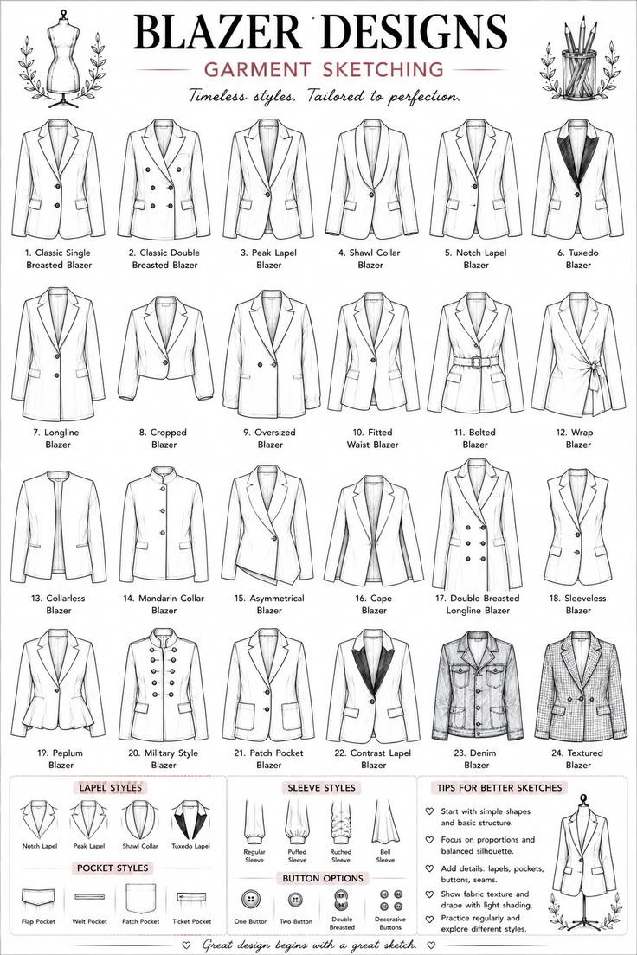
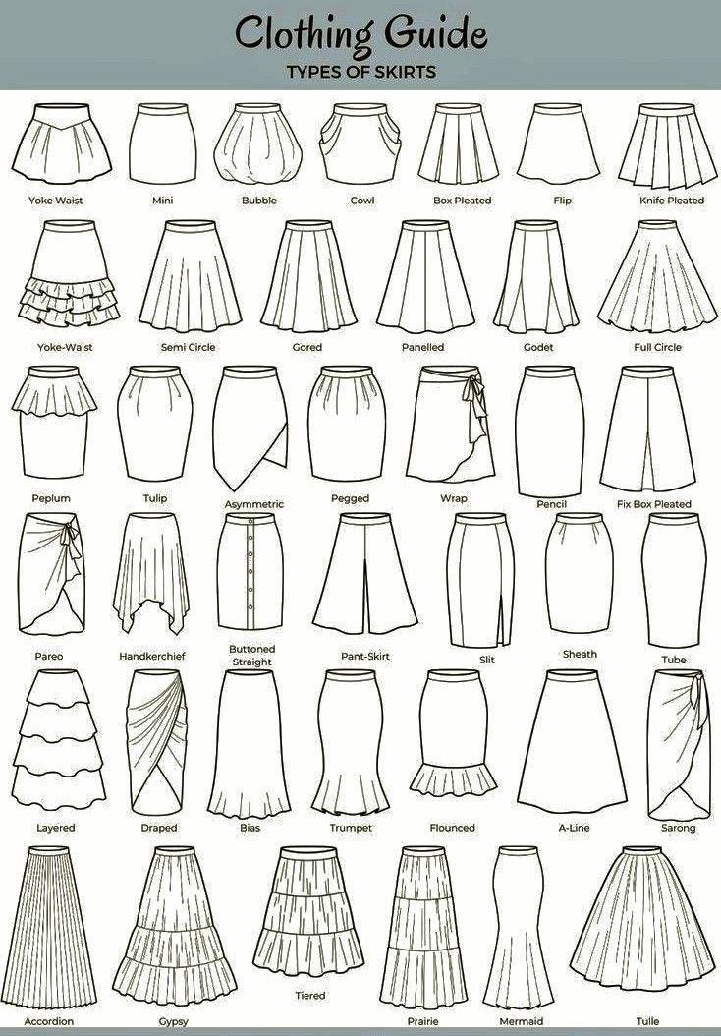
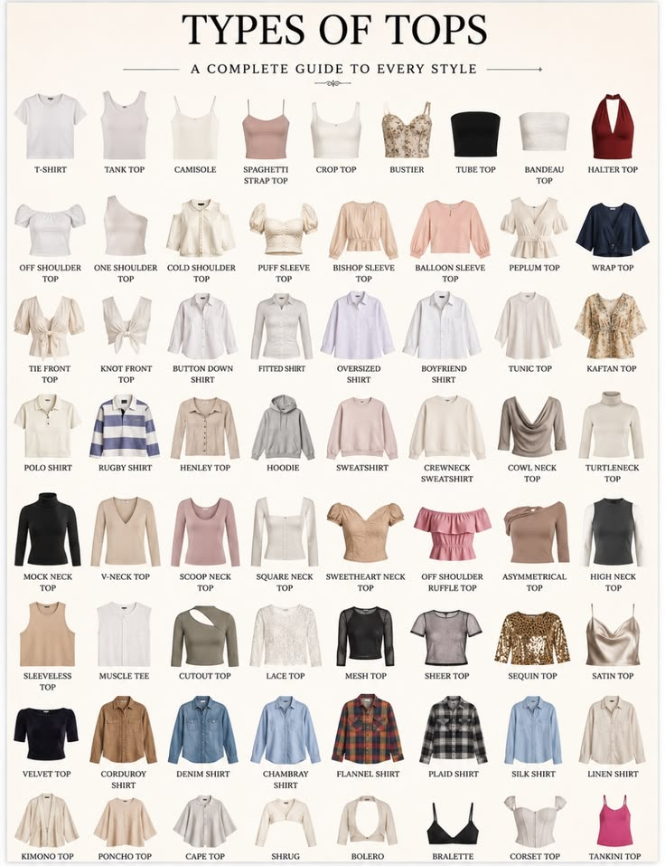

Dresses
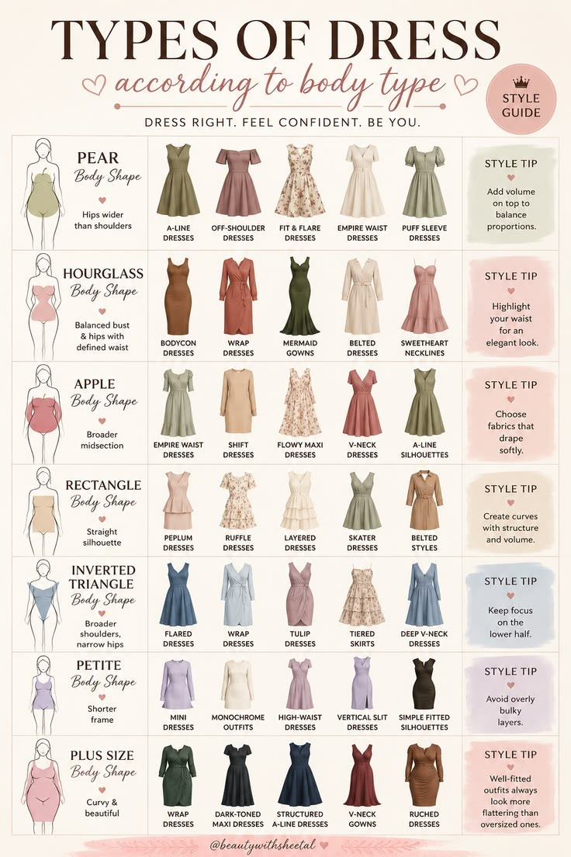

Crop tops
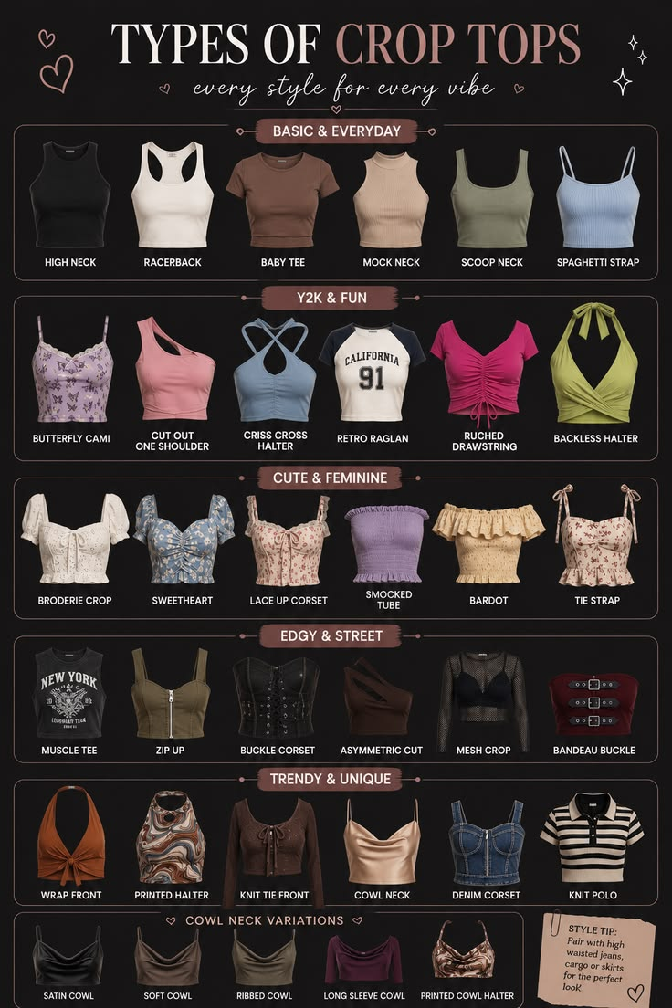

Bras
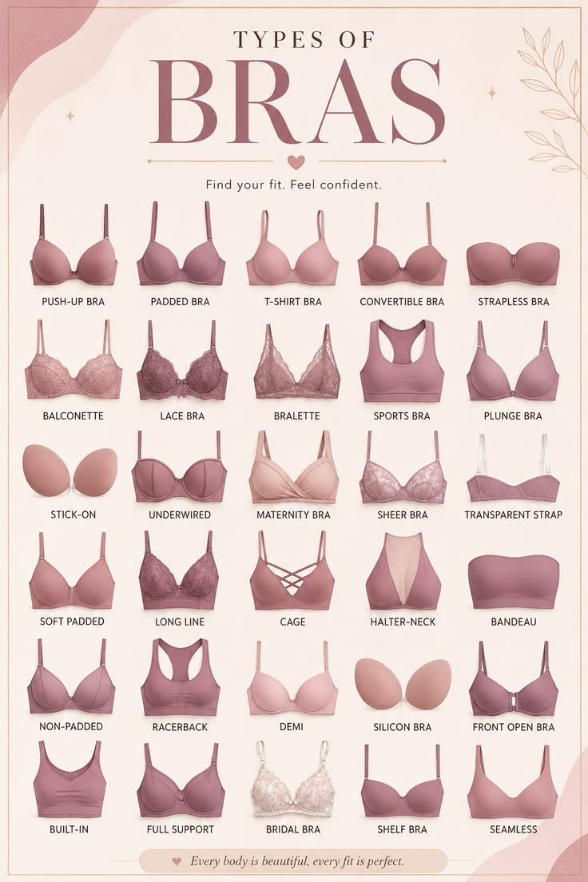

Fashion styles
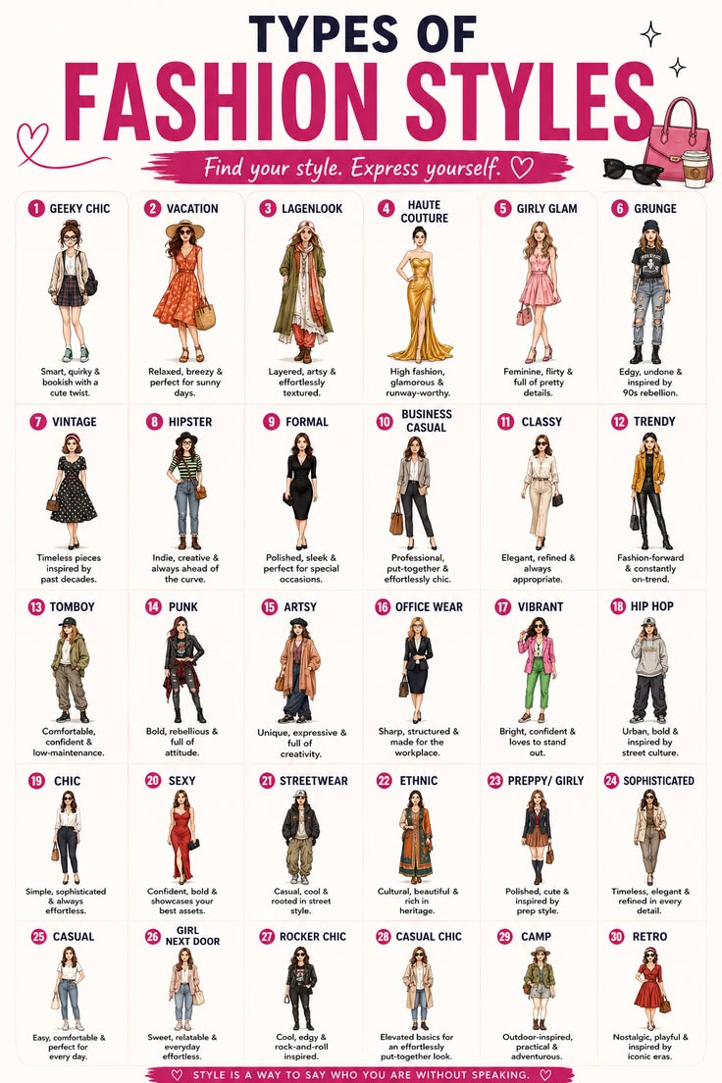

Lingerie
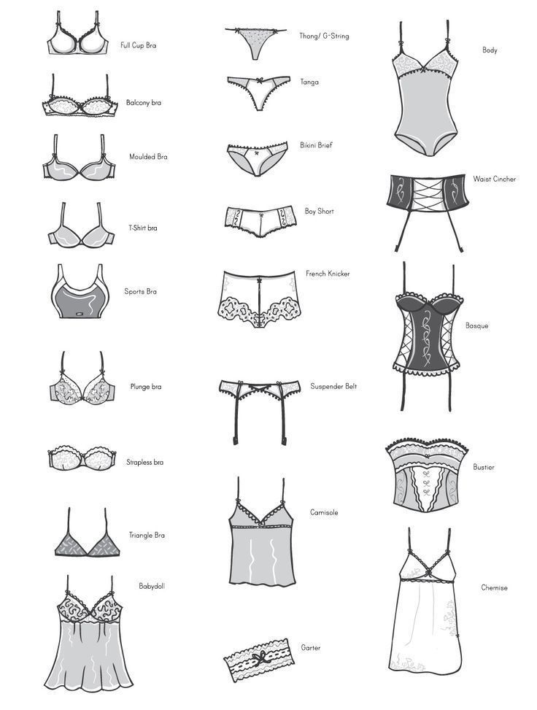
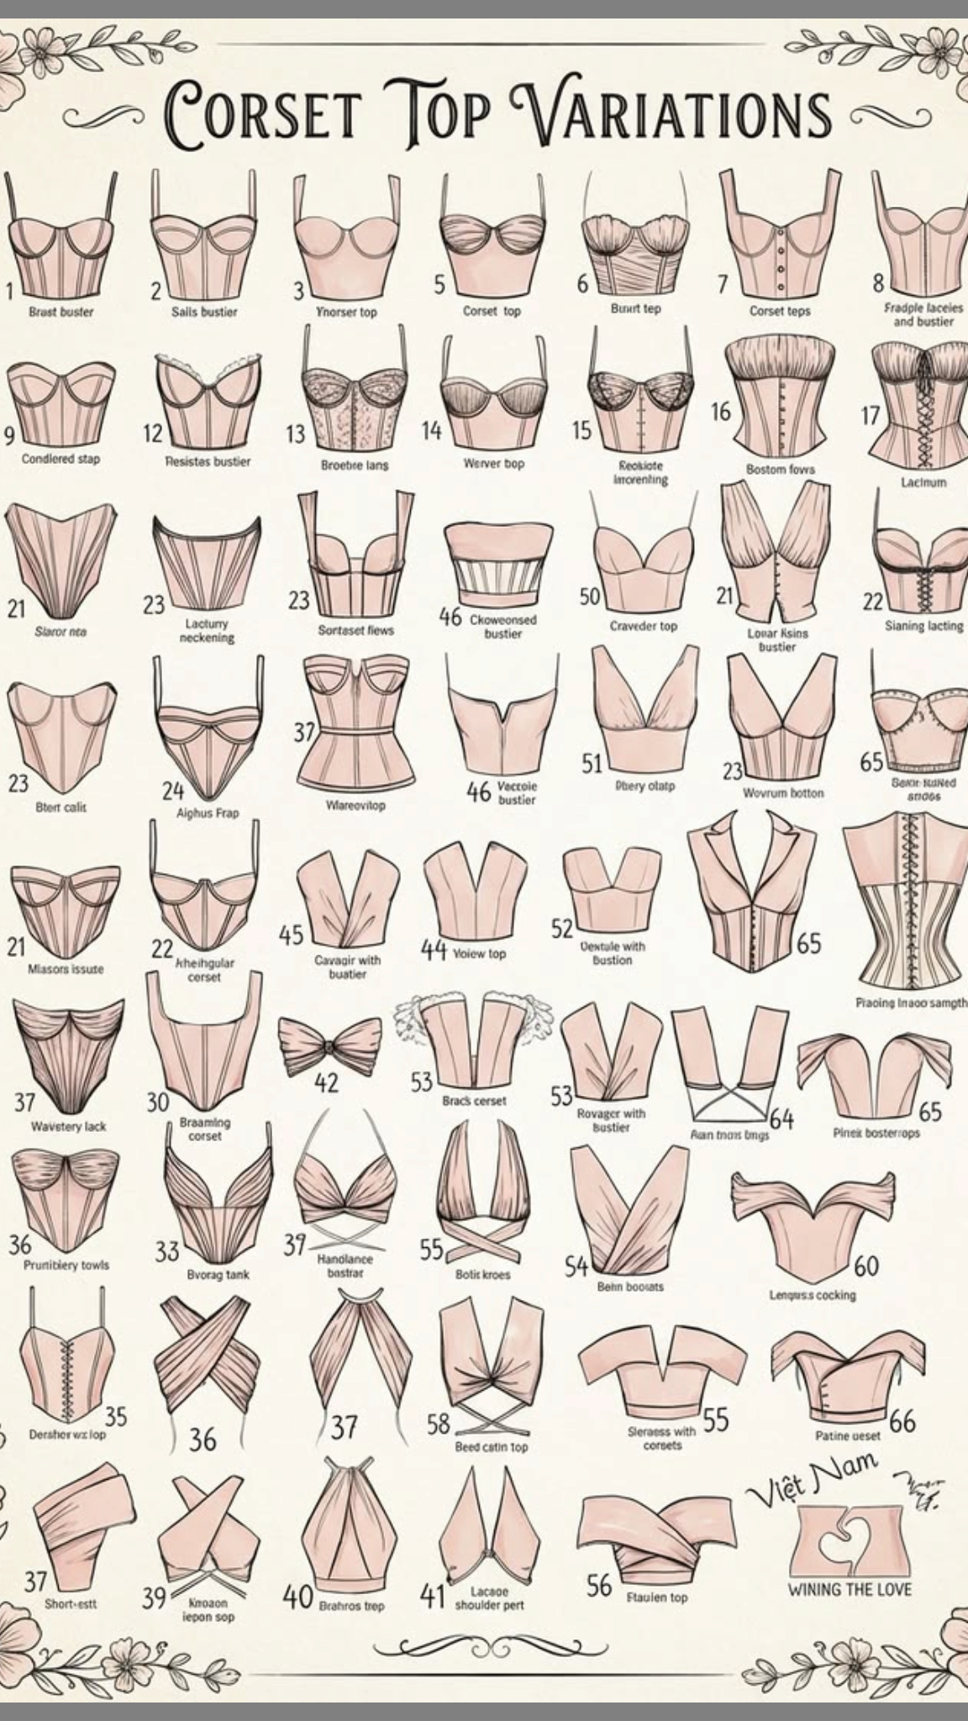

Hosiery
